**III. BUILD AND EVOLVE AGILE TEAMS**

Introduction

Lesson Introduction

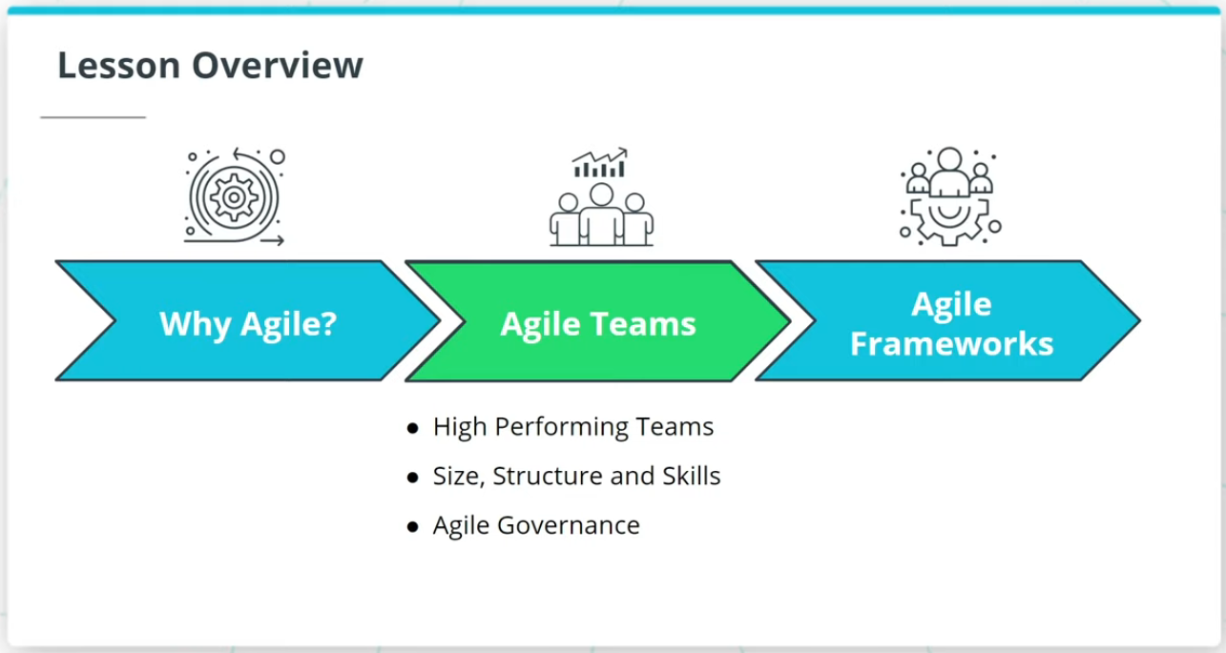

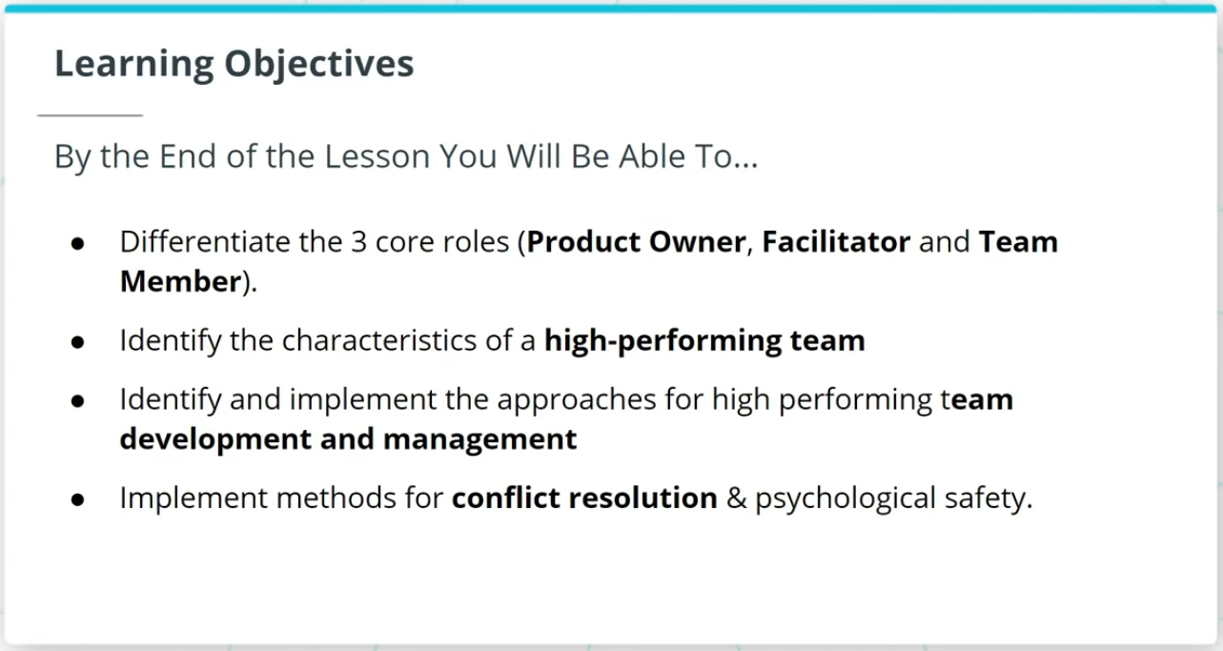

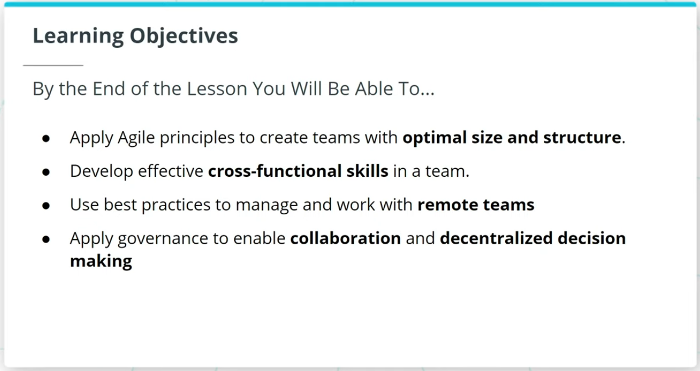

Welcome to a lesson on Agile Teams. In the last lesson, we talked about the importance of Agile.

This lesson will cover the following key topics:

### **High Performing Agile Teams**

* How Agile Teams are the vehicle that delivers valuable work tied to business-driven product features and functionality.
* Characteristics of a high-performing Agile Team.
* How to sustain High Performing Teams.

### **Size, Structure, and Skills of an Agile Team**

* The 3 core roles in Agile.
* An Agile Team’s optimal size, structure, and cross-functional skills.

### **Agile Governance**

* Agile Governance and how Agile governance leverages The Agile Manifesto’s guidelines to balance assurance with adaptability.

### **By the End of the Lesson, You Will Be Able To...**

* Differentiate the 3 core roles (Product Owner, Facilitator, and Team Member)
* Identify the characteristics of a high-performing team
* Identify and implement the approaches for high performing team development and management
* Implement methods for conflict resolution & psychological safety
* Apply Agile principles to create teams with optimal size and structure
* Develop effective cross-functional skills in a team
* Use best practices to manage and work with remote teams
* Apply governance to enable collaboration and decentralized decision making

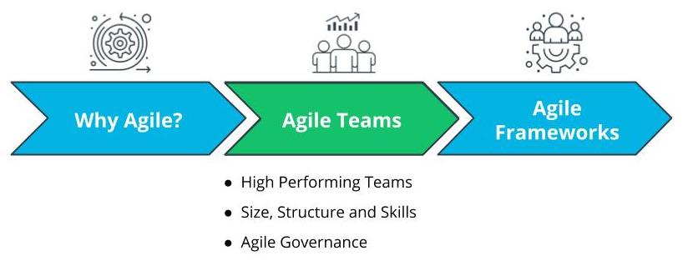

Lesson Overview - Agile Teams

# Why Agile Teams?

## Why Do Agile Teams Matter?

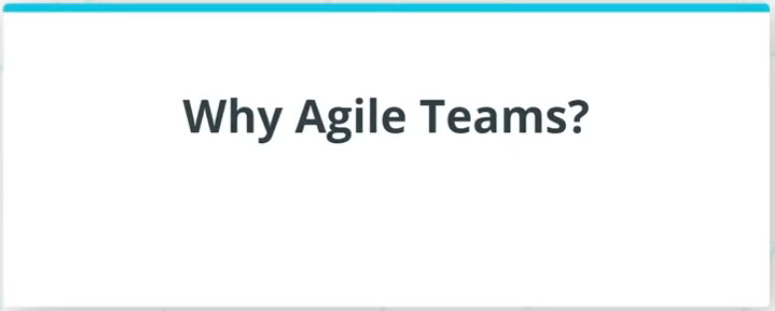

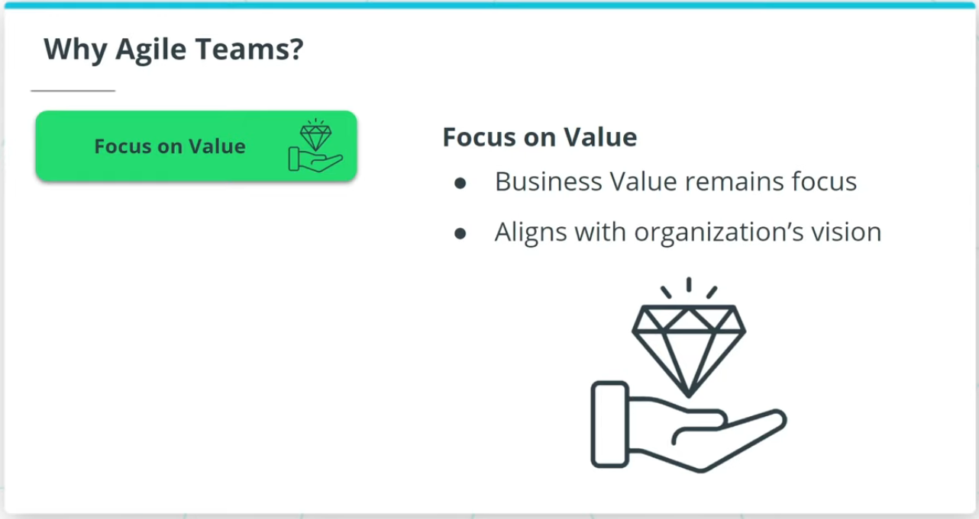

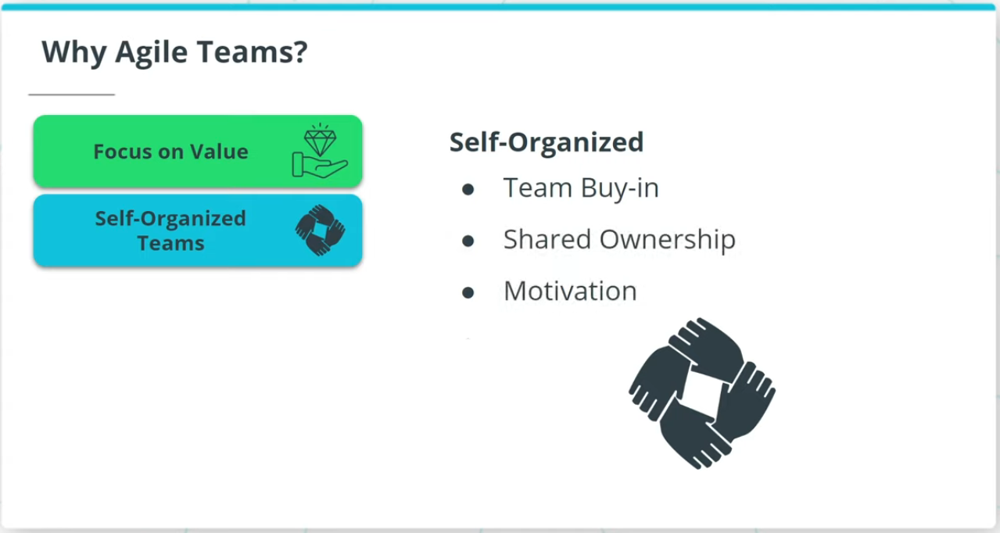

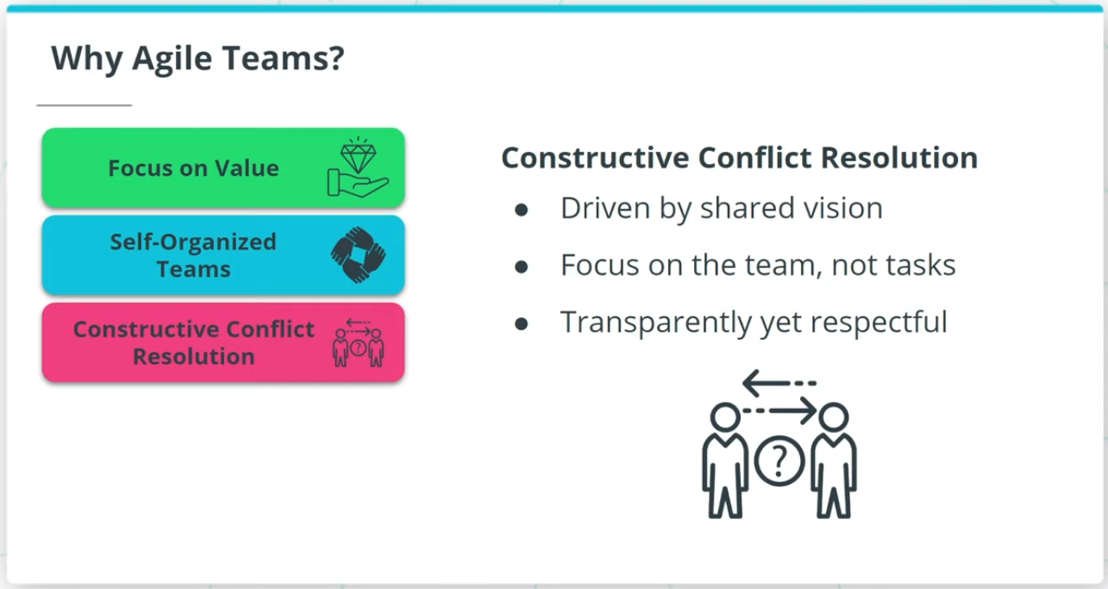

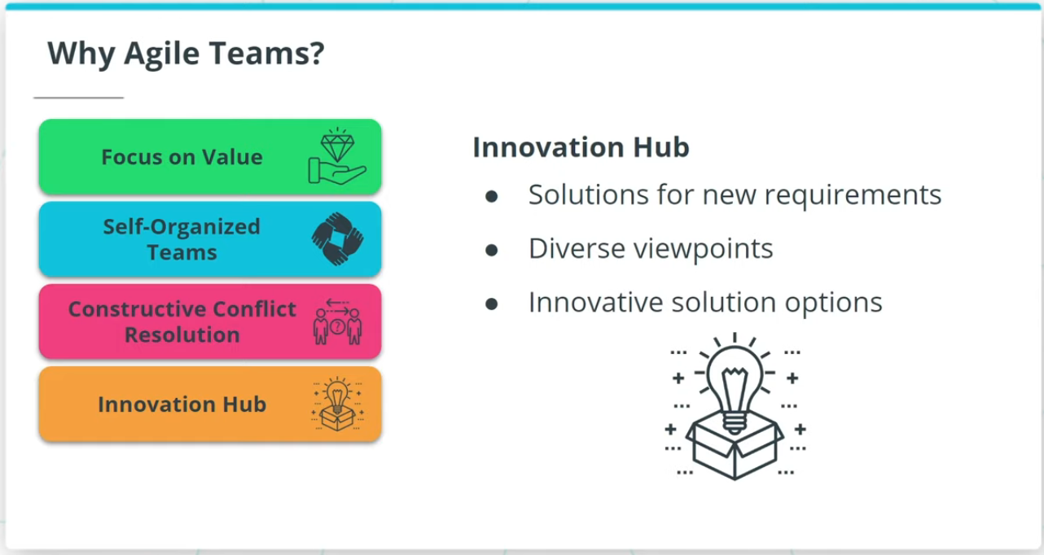

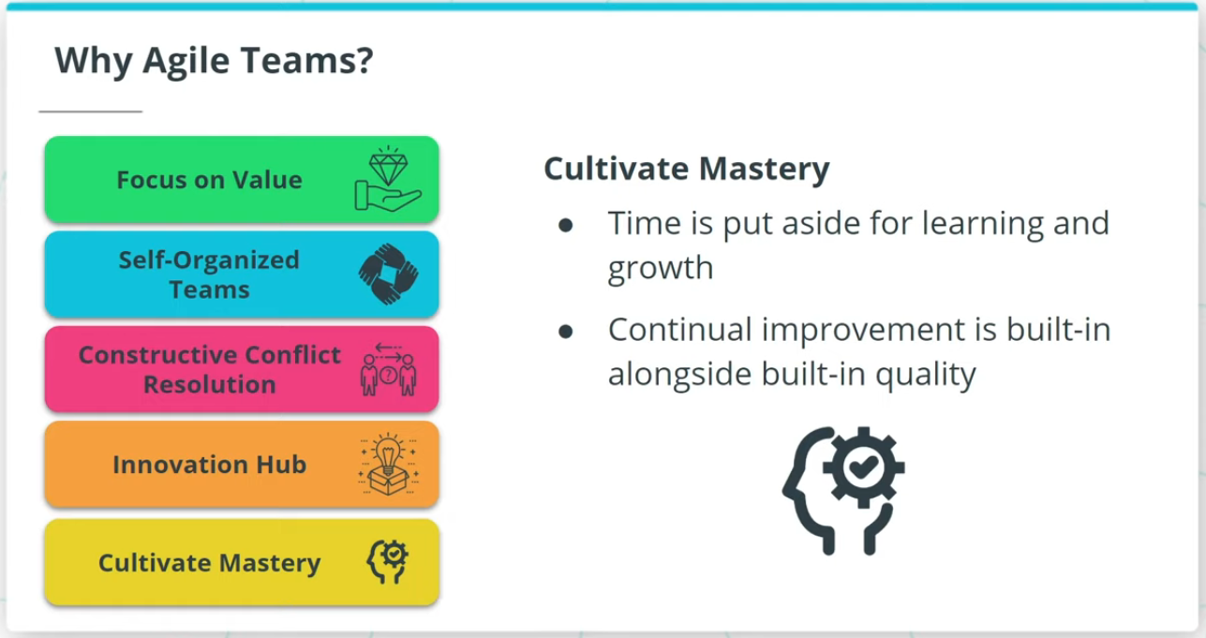

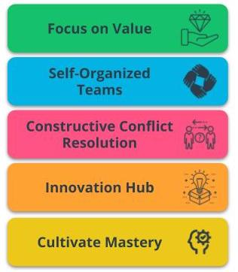

Benefits of Agile Teams

### **Agile Teams are a critical vehicle to deliver valuable results because of the following:**

* **Focus on Value** - Agile is driven by the goal of delivering maximum business value that is aligned with the organization’s vision.
* **Self-Organized Teams** - Agile Teams have the autonomy to make some de-centralized decisions, which allows for shared ownership of the work.
* **Constructive Conflict Resolution** - Conflicts in Agile Teams are constructively resolved because the team is driven by a shared vision.
* **Innovation Hub** - Agile Teams, with diverse and cross-functional skill sets, are an innovation hub that spurs solutions.
* **Cultivate Mastery** - Time is put aside in Agile Teams for learning and growth. This allows Agile Team members to sharpen their skills.

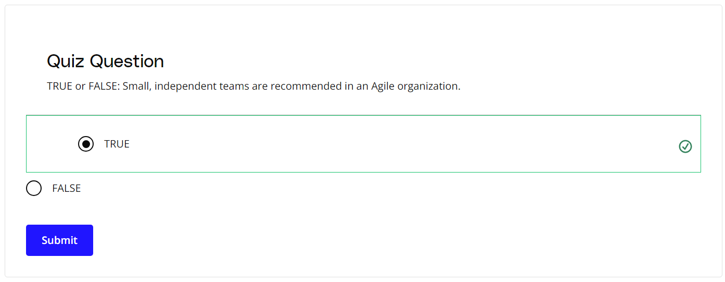

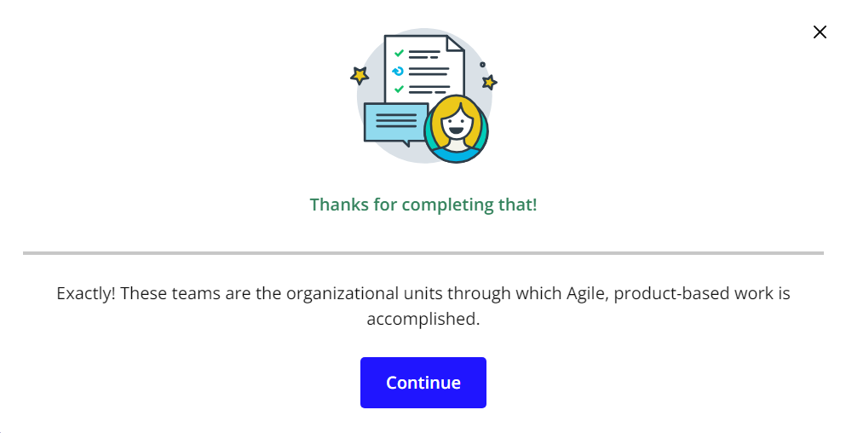

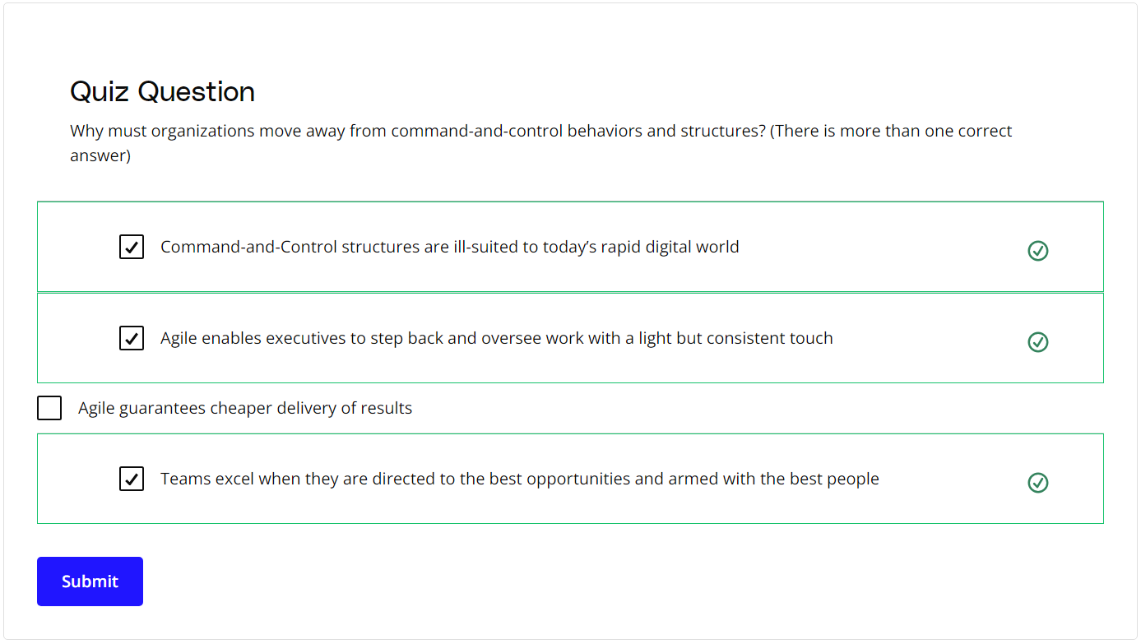

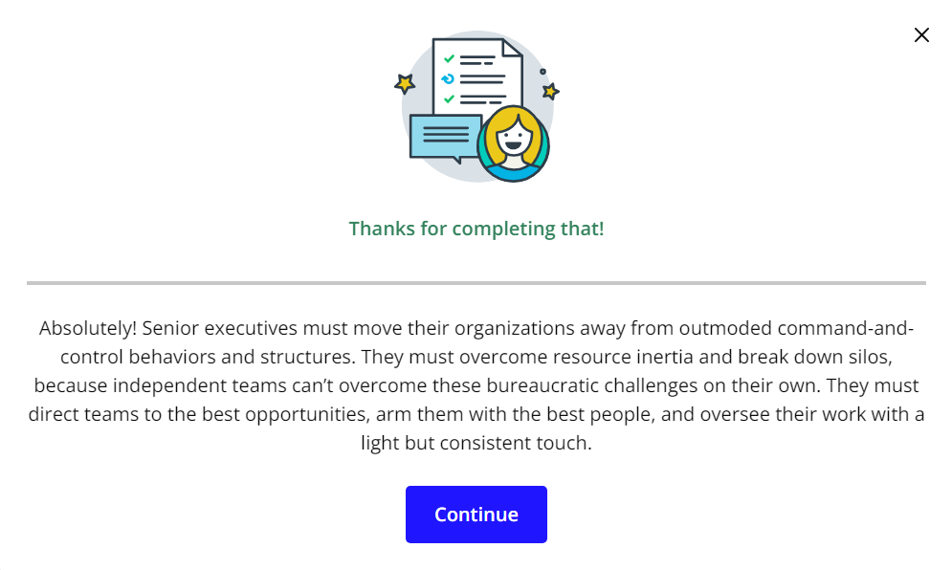

### **New Terms**

* **Innovation Hub**: Proactively working towards continual improvement with no compromise on technical excellence and quality
* **Self-Organized**: The team determines tasks and makes technical decisions about the work to be done after being given priorities by the Product Owner

### **Additional Resources**

* [**5 Ways to Organize Agile Teams**](https://www.scrumalliance.org/agile-resources/resources-for-your-agile-life/agile-advanced/may-2016/select-repost-5-ways-to-organize-agile-teams): This blog post from the Scrum Alliance describes five techniques to organize Agile teams successfully.

# How Experts Approach Agile Teams

## Thinking About Agile Teams

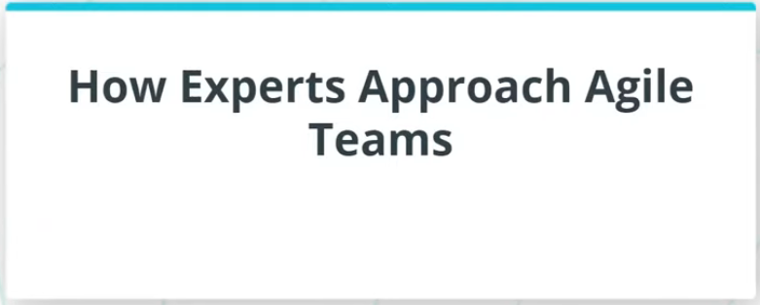

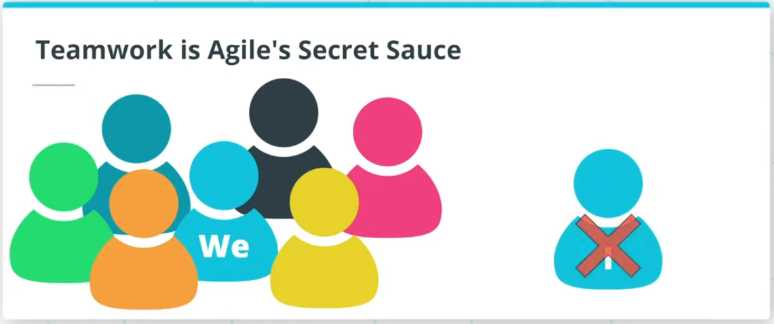

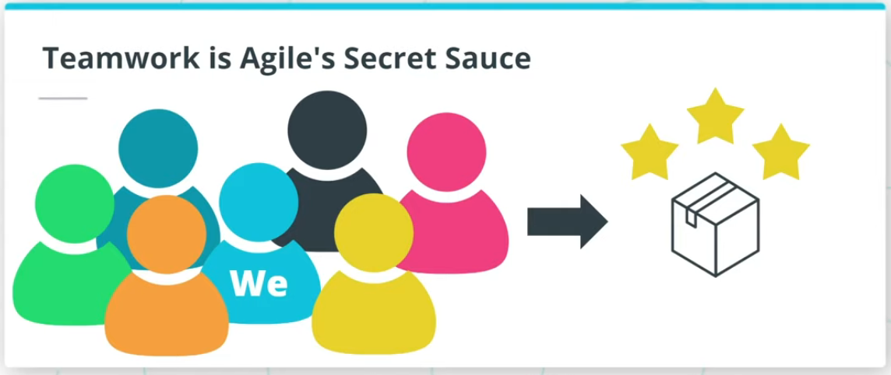

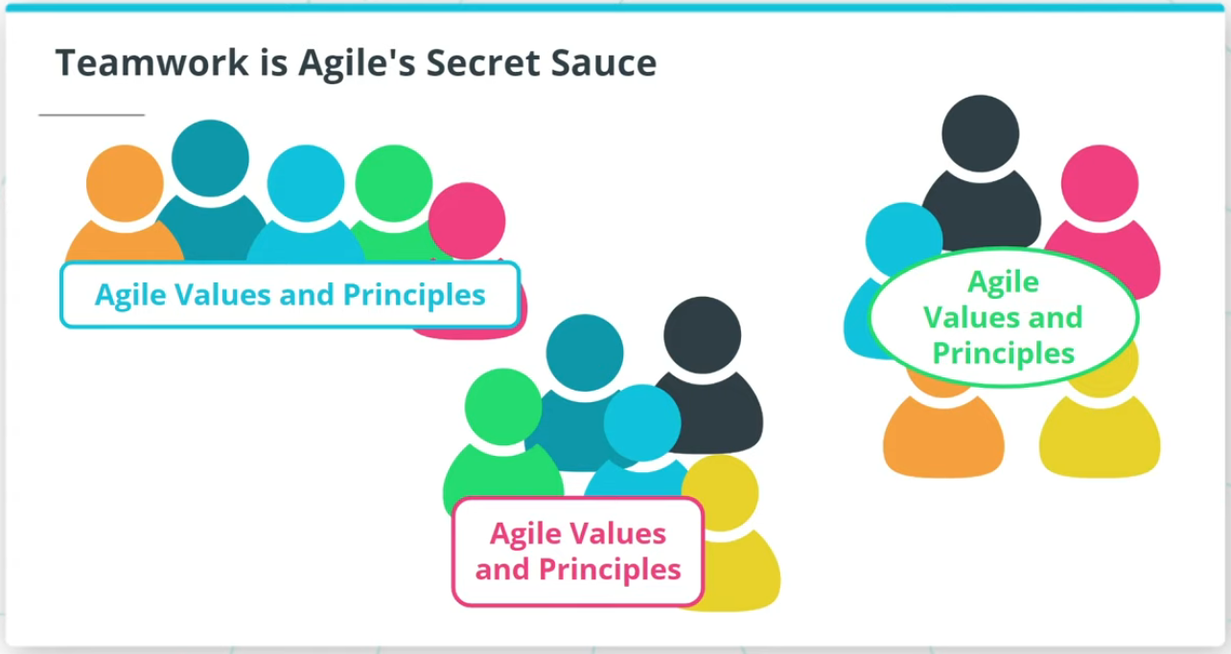

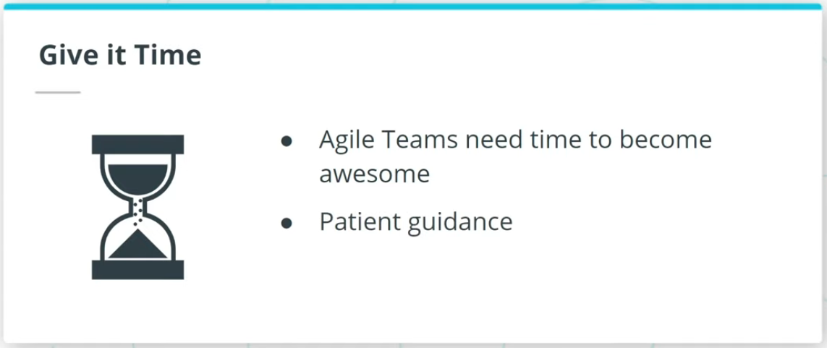

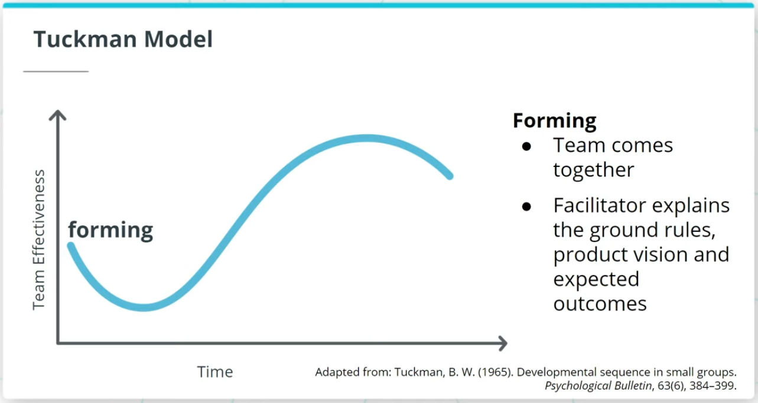

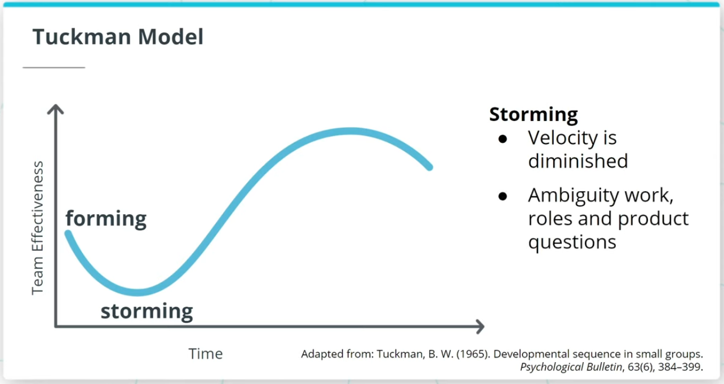

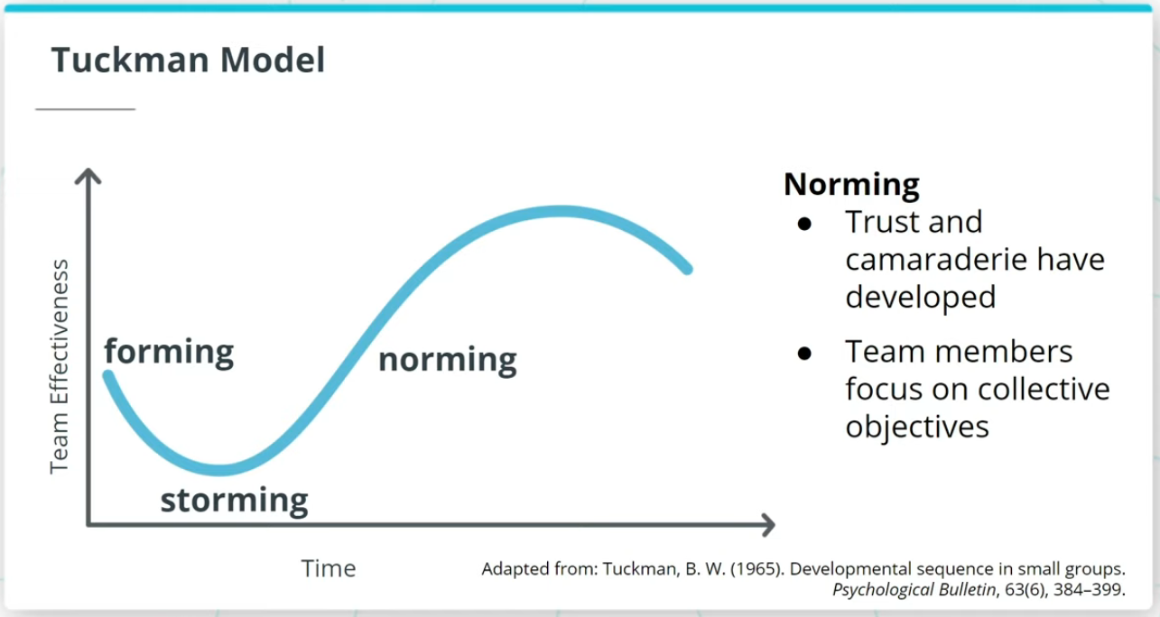

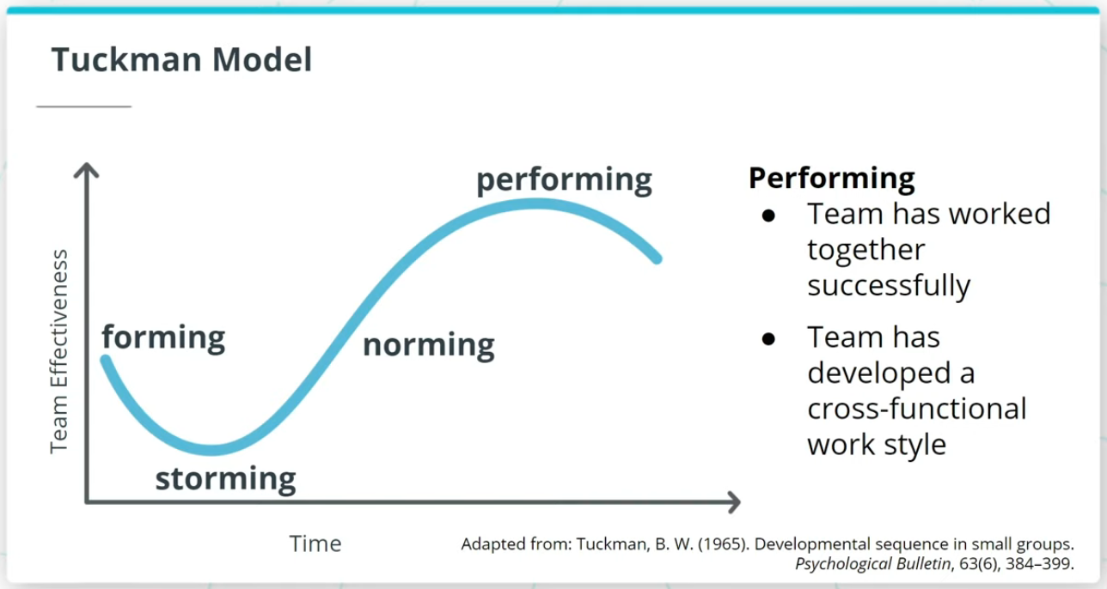

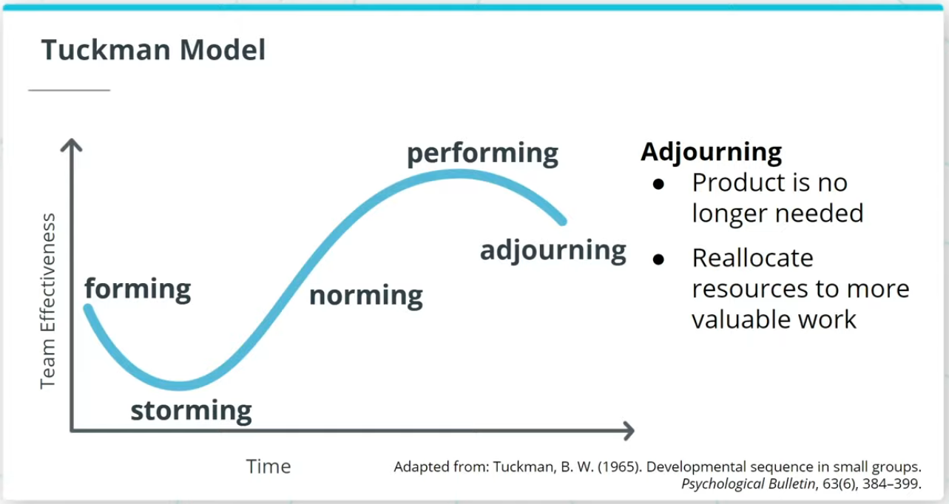

### **Key Points About High Performing Teams**

* Agilists believe that nothing is more critical to delivering exceptional products than teamwork.
* Agile Teams live and breathe the "we" mindset rather than “I."

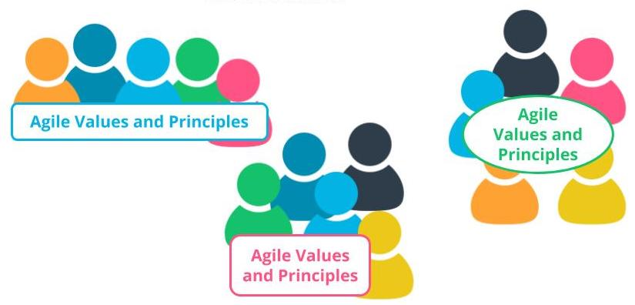

Teamwork is Agile's Secret Sauce

### **Tuckman Model**

The Tuckman Model, which has 5 stages of team development, describes how an Agile team progresses into an awesome Agile squad.

* **Forming** - Agile Team comes together and the Facilitator helps the team form by explaining the ground rules, product vision, and expected outcomes.
* **Storming** - This is where a team’s velocity is impacted because there tends to be some confusion and ambiguity around the work to be done, roles, and other product-related questions.
* **Norming** - Agile Team members develop a sense of trust and camaraderie. There’s a healthy rapport and each team member starts to look for the collective objectives of the team’s long-term success.
* **Performing** - Once an Agile Team has successfully worked together over a few iterations they should be in a state where they have gelled together and developed a strong cross-functional work style.
* **Adjourning** - If the business leaders realize that a product is not delivering value or is no longer needed in the market, the existing Agile Team members can be re-allocated to other more valuable work in the organization.

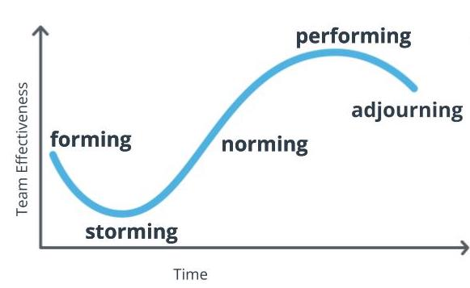

**The Tuckman Model**  
Adapted from: Tuckman, B. W. (1965). Developmental sequence in small groups. Psychological Bulletin, 63(6), 384–399.

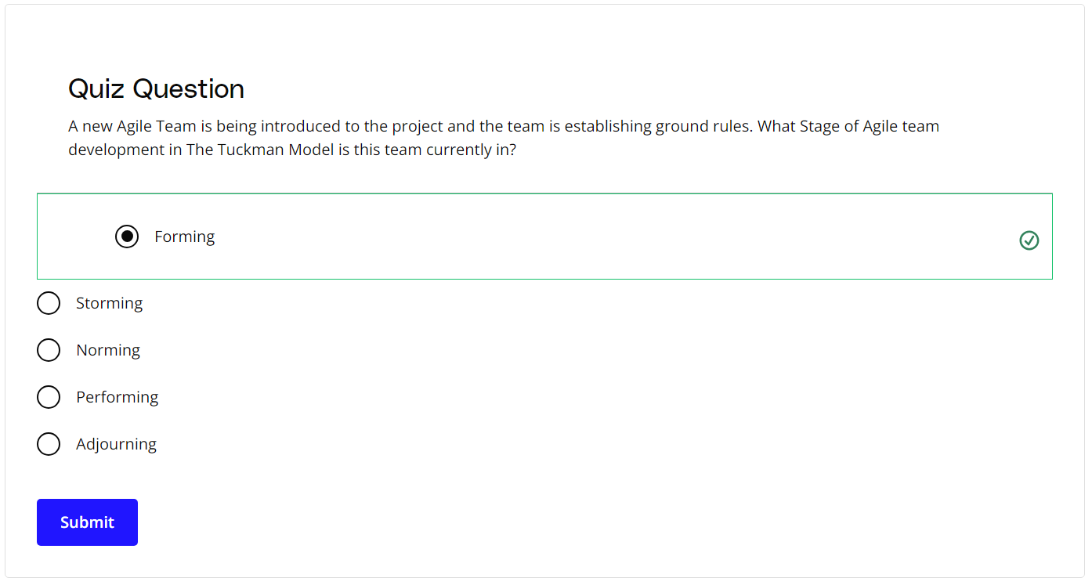

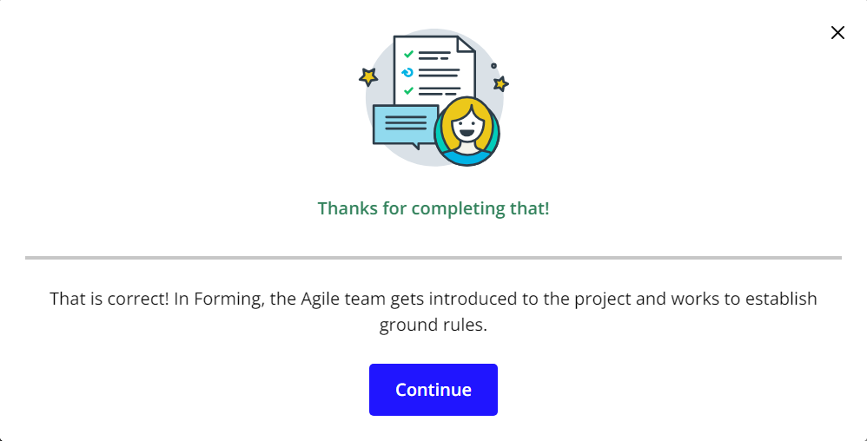

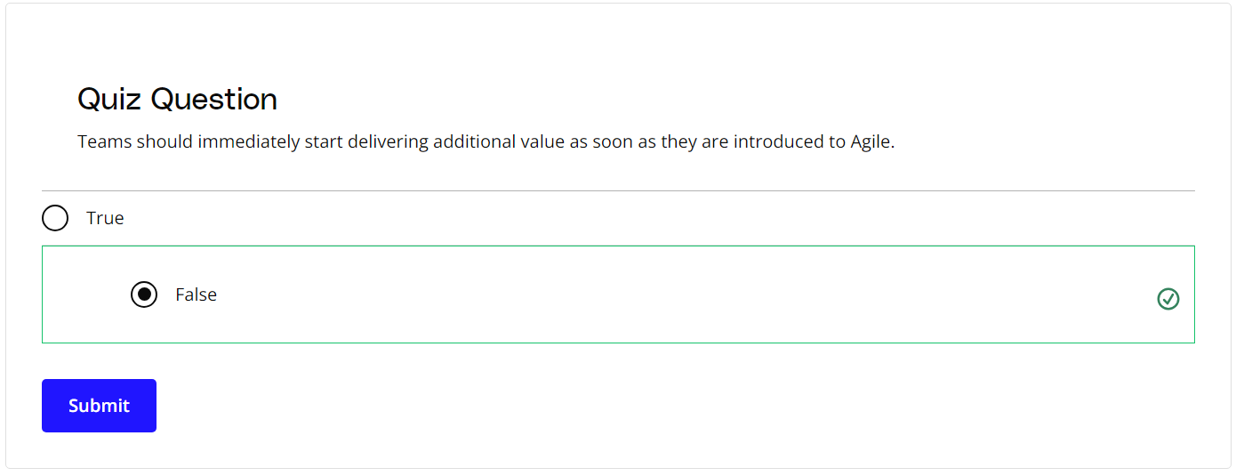

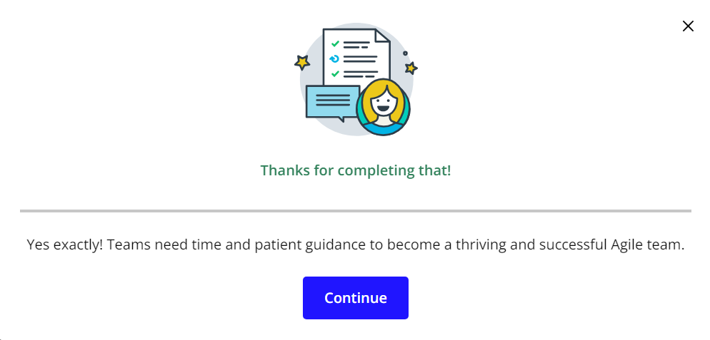

### **New Terms**

* **Adjourning**: The stage in the Tuckman Model where the Agile team’s goals have been completed, and the focus is on wrapping things up before team members get reassigned to other work
* **Forming**: The stage in the Tuckman Model when the team is getting accustomed to each other, ground rules are being established, and everyone is informed of the goals and objectives
* **Norming**: The stage in the Tuckman Model where a sense of trust develops among team members; interpersonal differences are taken care of now, and a sense of collaboration for the team's collective benefit arises
* **Performing**: The stage in the Tuckman Model where the team has matured into a well-established unit with a sharp focus on collaborative value delivery
* **Storming**: The stage in the Tuckman model where the team goes through a level of chaos in which there is confusion around the goals and objectives of the project, as well as confusion around roles and responsibilities

### **Additional Resources**

* [**High-Performance Teams - Why the Who Matters Less**](https://www.scrumalliance.org/agile-resources/resources-for-your-agile-life/agile-advanced/march-2017/high-performance-teams-why-the-who-matters-less): Fabian Schwartz discusses how the collective team is more important than having superstars on board.
* B W Tuckman, ***Developmental Sequence in Small Groups***, Psychological Bulletin 63, 1965.  
  This is where Bruce Tuckman first introduced the Tuckman Model.

# Three Core Roles

## What Are the Three Core Roles?

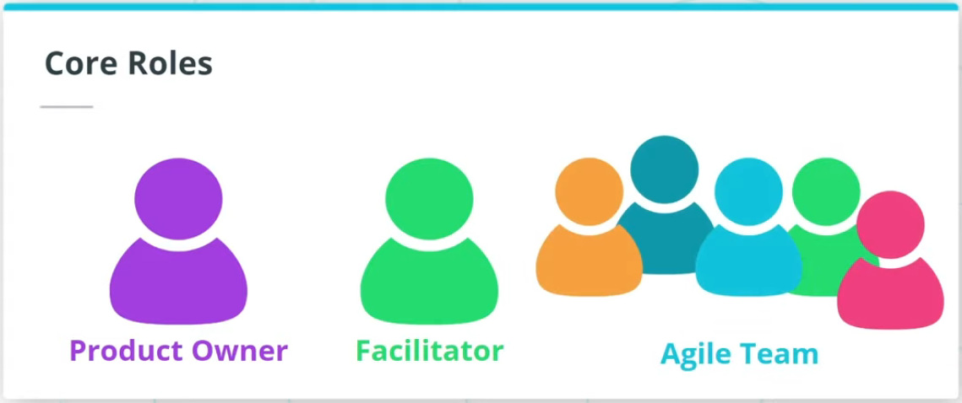

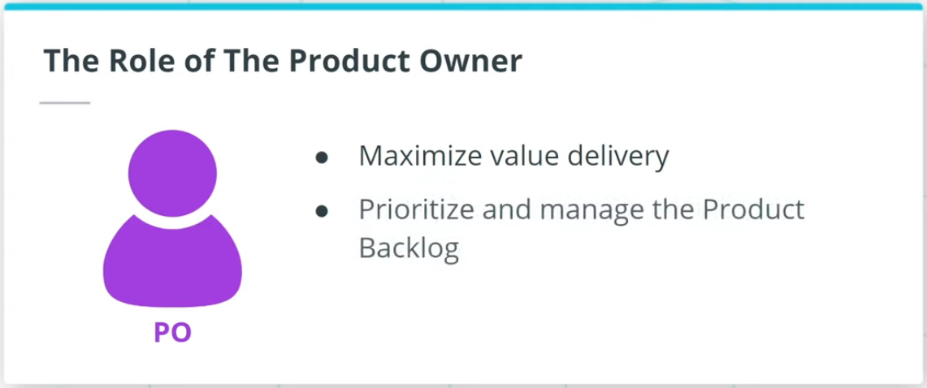

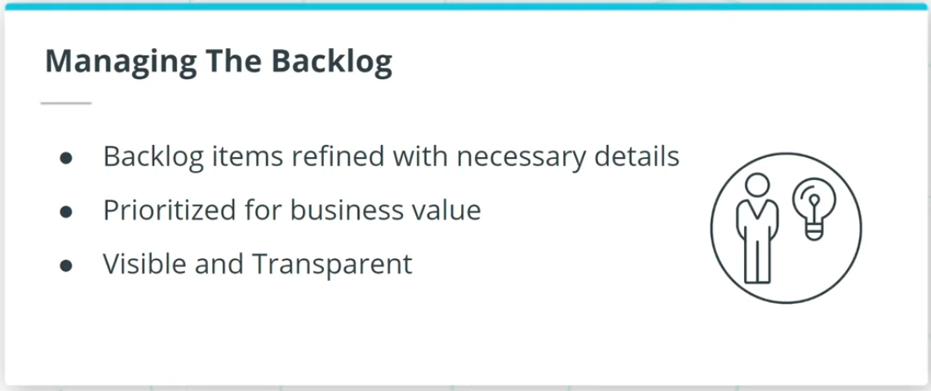

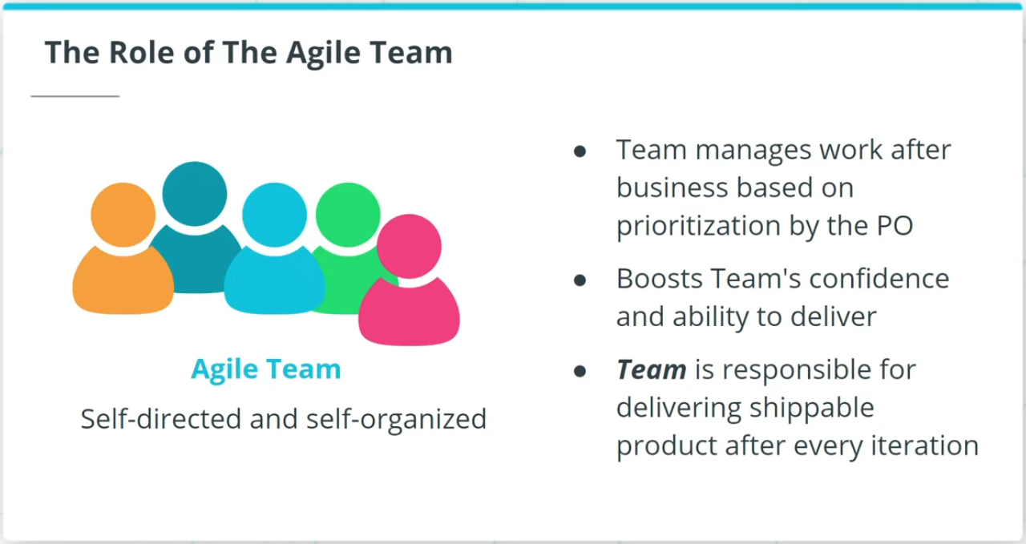

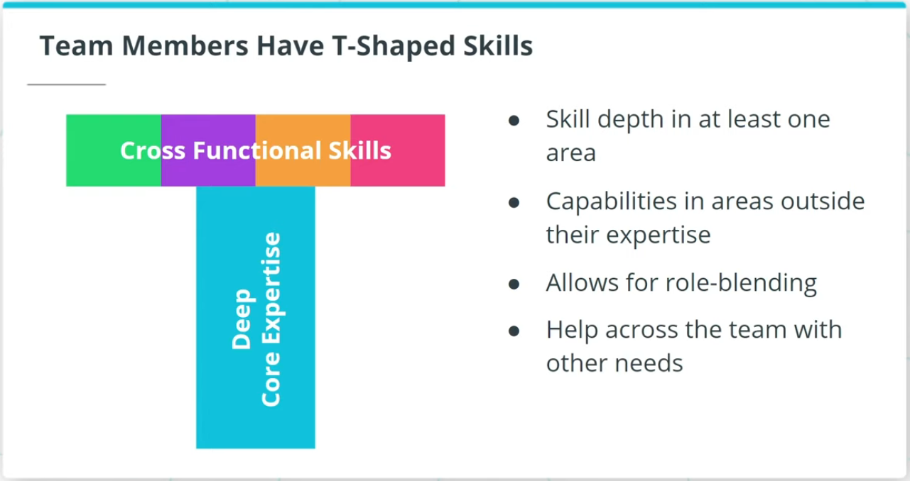

### **Three Core roles in Agile Frameworks: Product Owner, Facilitator, and Agile Team**

* A **Product Owner**, often referred to as PO in short, is responsible for working with both The Agile Team as well as the business to maximize the value of the product deliverables being worked on. The Product Owner is primarily responsible for prioritizing and managing the Product Backlog, or the prioritized work item list.
* **Agile Teams** are self-directed and self-organized. The Agile Team members are the ones who accomplish the actual work of completing and delivering a potentially shippable version of the product at the end of each Iteration.

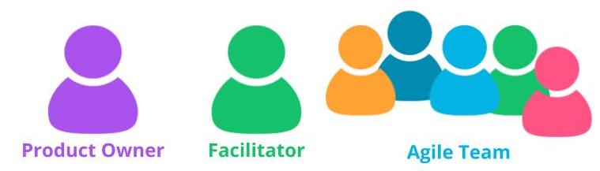

Three Core Roles in Agile

### **Agile Team Members Exhibit T-Shaped Skills**

When Agile Team members exhibit T-Shaped skills:

* They have tremendous expertise in at least one area.
* They are also capable of providing value in other areas outside their expertise.
* Team members are able to do role blending by going beyond their core vertical skill set.

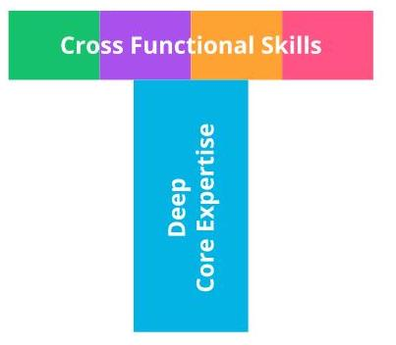

Agile Team Members Exhibit T-Shaped Skills

## Facilitator As Servant Leader

### **To Serve and Support**

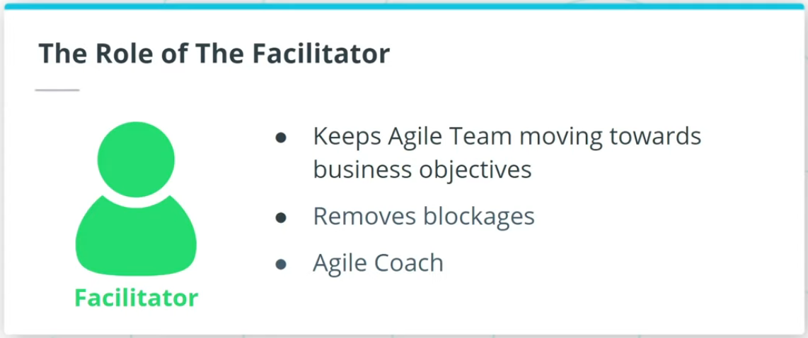

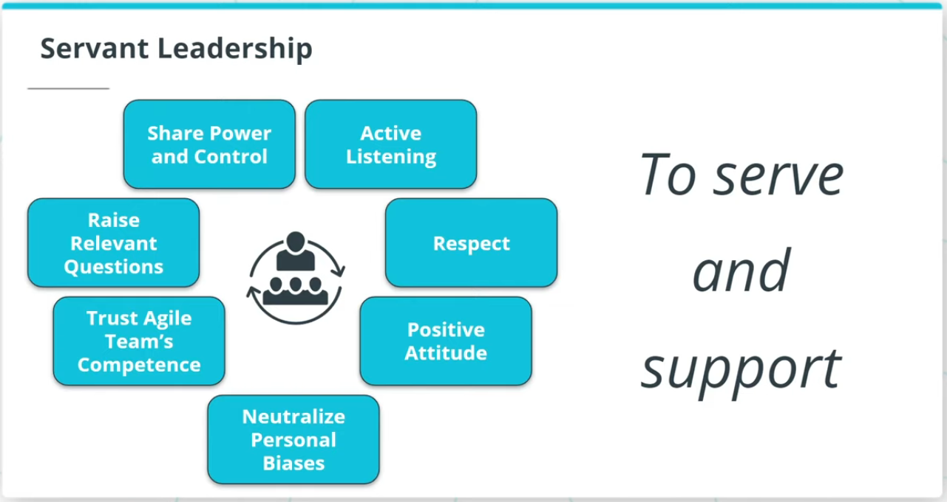

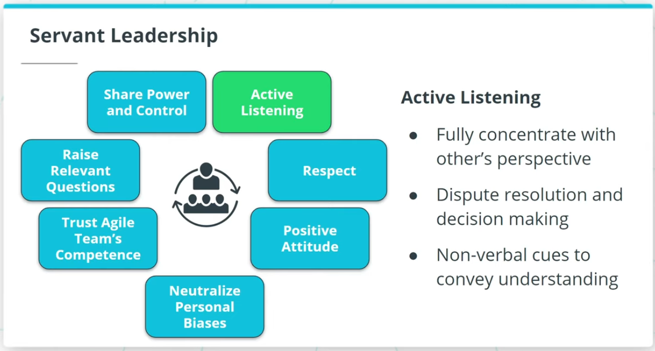

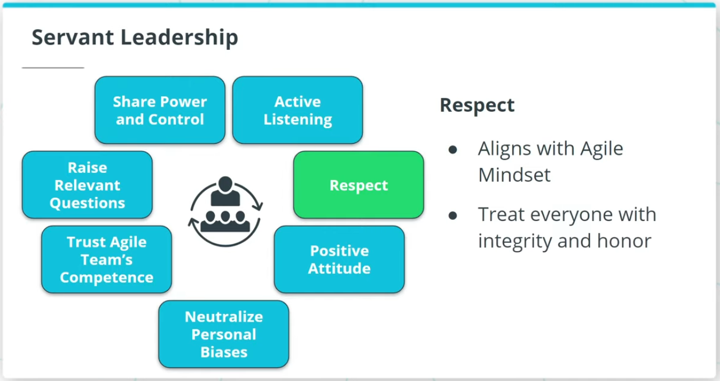

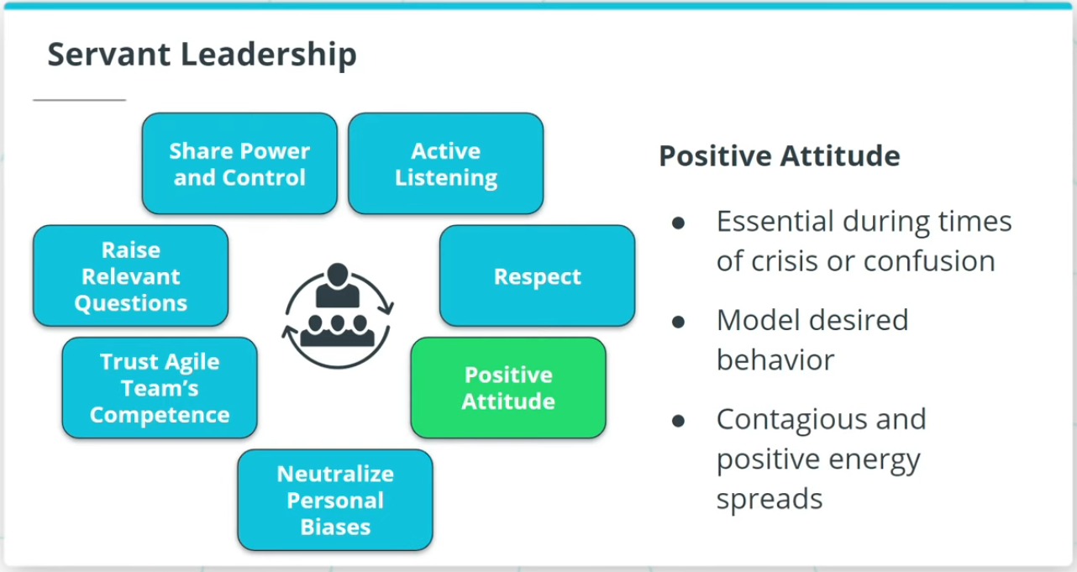

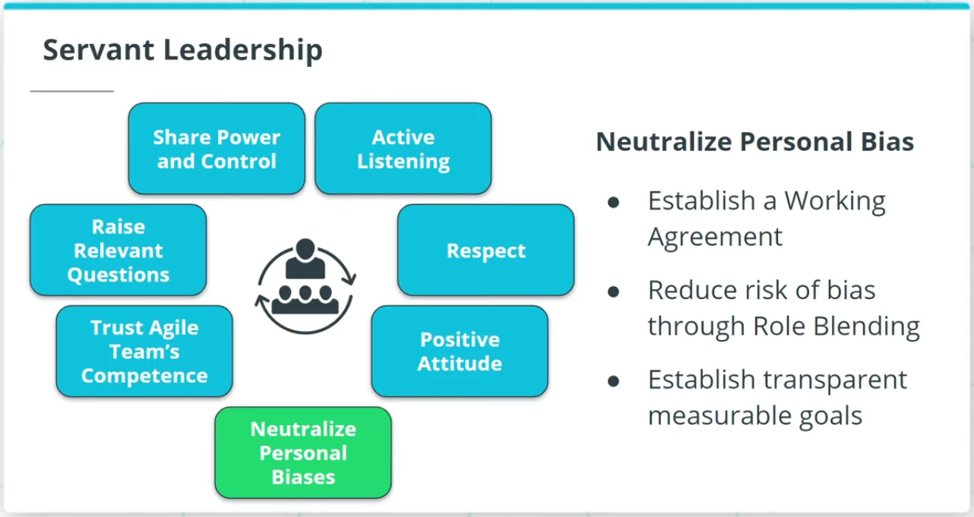

The Facilitator is responsible for ensuring the Agile Team moves along at an acceptable pace. The Facilitator is also usually an Agile Coach who promotes Agile practices and values.

### **Facilitators are Servant Leaders Who Serve and Support**

Servant Leadership adopts a leadership viewpoint in which the leader positions himself or herself to serve and support. Servant Leadership includes:

* Active listening
* Respect
* Positive attitude
* Neutralize personal biases

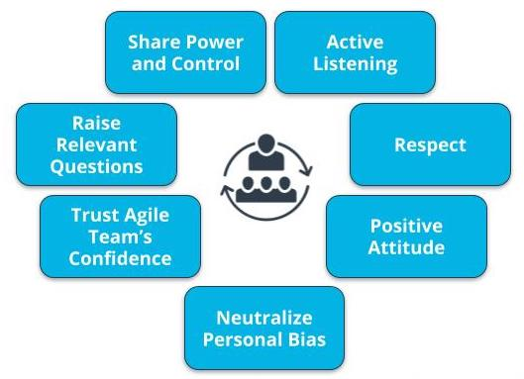

Characteristics of Servant Leadership

### **Servant Leadership Helps the Team Deliver Results**

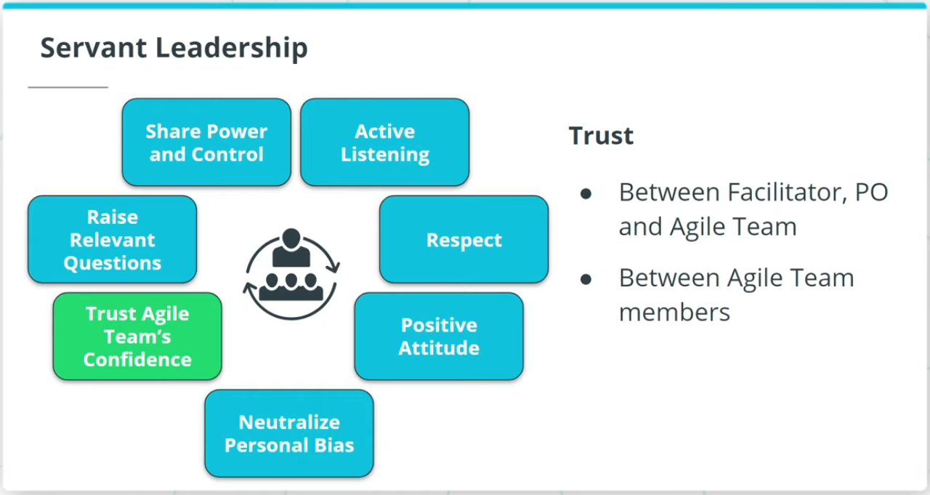

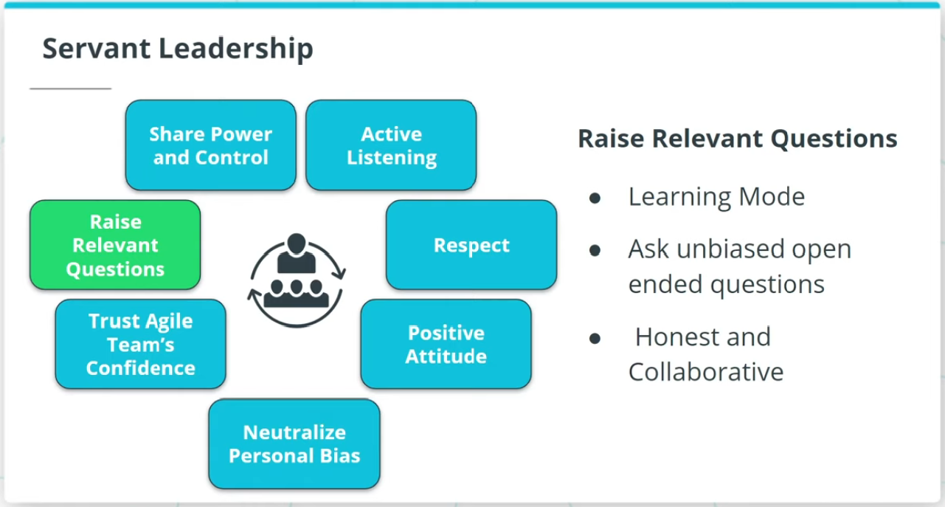

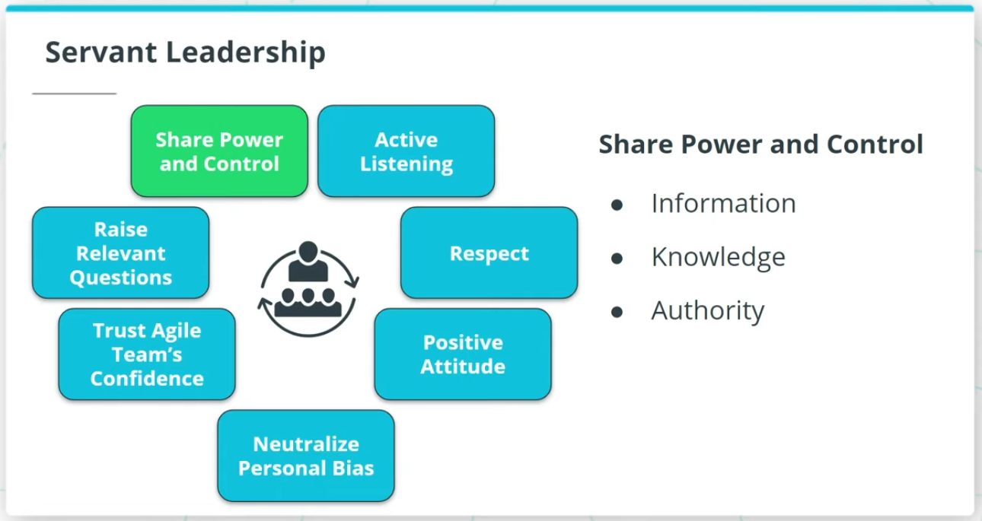

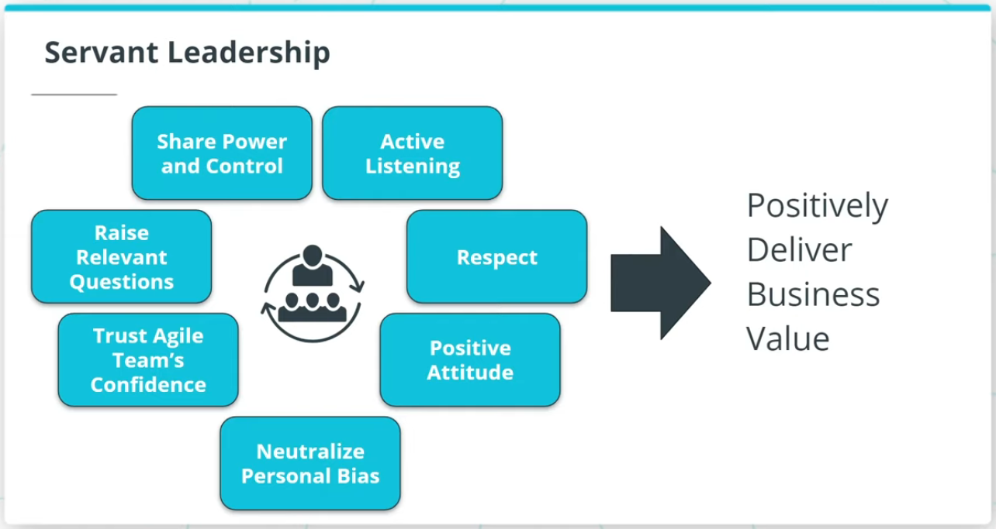

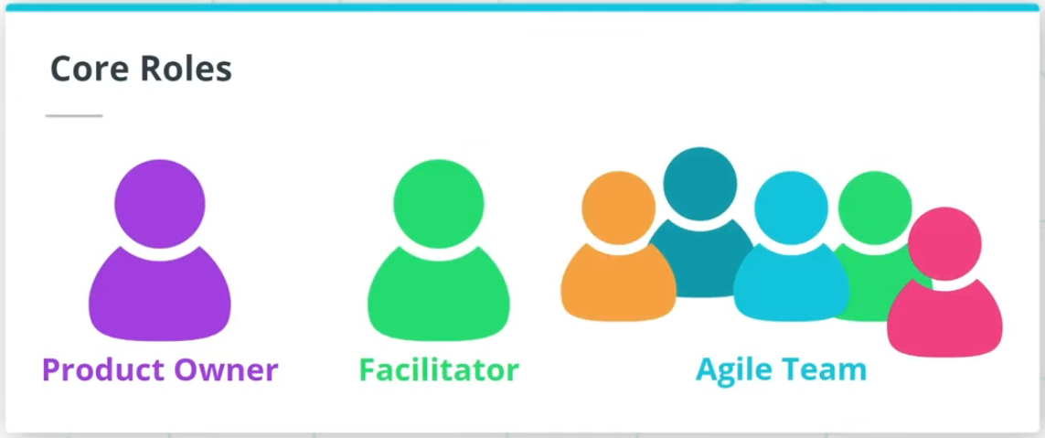

Servant Leadership also includes:

* Trust Agile Team’s competencies
* Raise relevant questions
* Shares power and control

Servant Leadership helps a Facilitator build a high-performing Agile team, which in turn enables the Facilitator to truly help the Agile Team achieve results that positively deliver business value.

### **New Terms**

* **Facilitator**: The person who ensures that the Agile Team moves along at an acceptable pace towards the business objective and removes any blockages or impediments that may be slowing the team
* **Self-Directed**: Team members are empowered to decide among themselves who does what and how it is to be accomplished in a collaborative manner
* **T-Shaped Skills**: A strong vertical skill combined with the capability and willingness to step into other cross-functional needs
* **Team Member**: The people who accomplish the actual work of completing and delivering a potentially shippable version of the product at the end of each iteration

### **Additional Resources**

* [**The Elusive Product Owner**](https://www.scrumalliance.org/agile-resources/resources-for-your-agile-life/agile-advanced/march-2016/select-repost-the-elusive-product-owner): This Scum Alliance post discusses the critical role POs play in Agile teams.

# Quizzes: Three Core Roles

## Thinking About the Three Core Roles

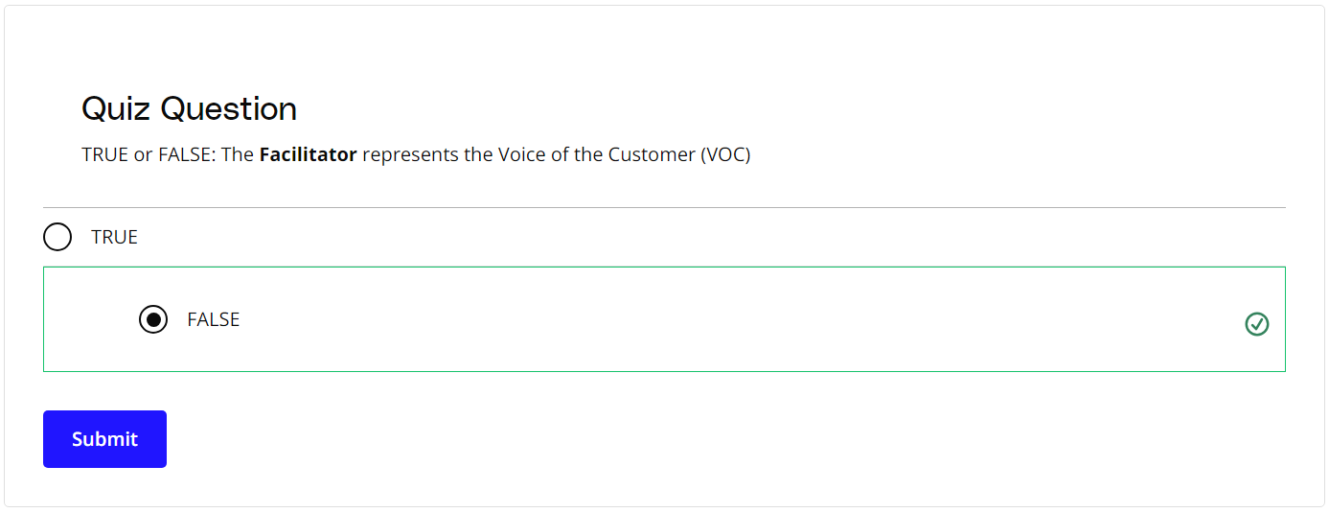

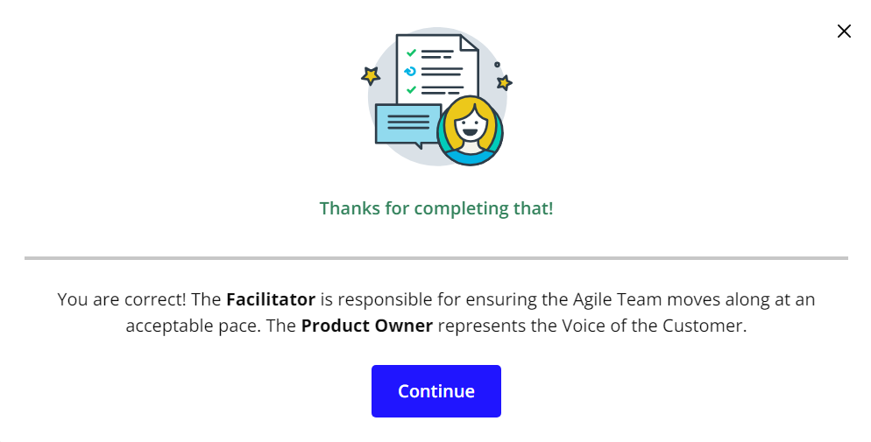

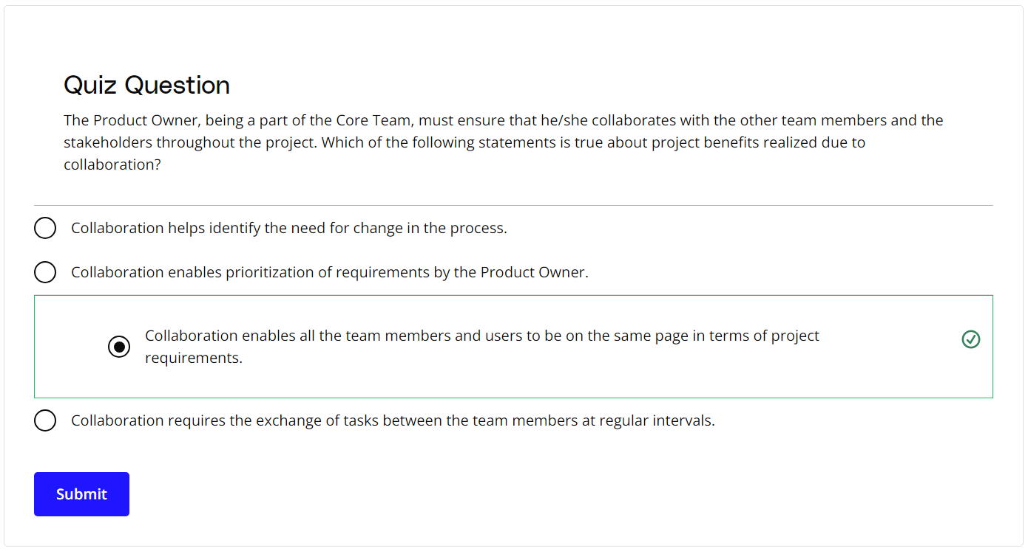

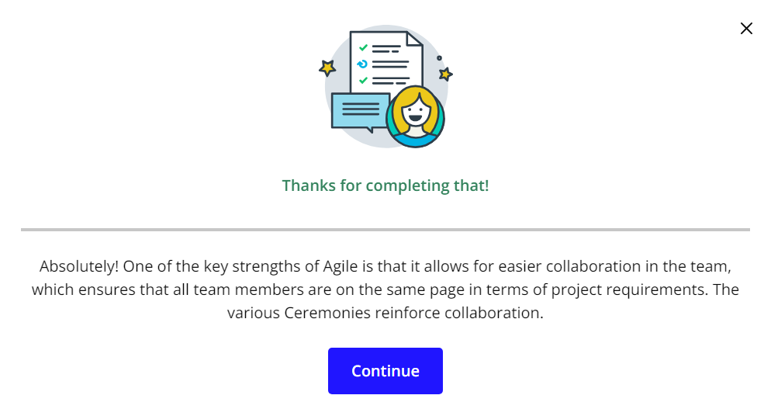

# Exercise: Three Core Roles

## Assigning the Three Core Roles

As SocialKare.gov starts on its Agile transformation, the team will need to fill the core Agile roles.

Review the [**SocialKare.gov Case Study**](https://video.udacity-data.com/topher/2020/September/5f5f6bc7_agnd-c1-foundations-of-agile-socialkare.gov-case-study/agnd-c1-foundations-of-agile-socialkare.gov-case-study.pdf) and

* Identify the three Agile Core roles and their responsibilities in the SocialKare.gov context
* Assign one of the listed SocialKare.gov employees to the Core Agile Roles
* Explain your assignments



### **Key SocialKare.gov Employees**

This information also is available in the [**SocialKare.gov Case Study**](https://video.udacity-data.com/topher/2020/September/5f5f6bc7_agnd-c1-foundations-of-agile-socialkare.gov-case-study/agnd-c1-foundations-of-agile-socialkare.gov-case-study.pdf).

* **John Details**: John is a detail-oriented individual who likes to plan everything out in tremendous detail. He has several years of experience as a Technical Project Manager. Prior to stepping into the role of Project Manager, John was a Developer. He is known to have good communication skills.
* **Sarah Tenure**: Sarah has been with the Agency responsible for launching SocialKare.gov for over 2 decades. Sarah has a lot of business knowledge and carries a certain amount of credibility due to this tenure. Sarah is strong-headed and likes to make decisions based on how she sees things because she believes she has better insight than others who may have been with the organization for as long as she has.
* **Tim Devs**: Tim has excellent technical skills. He prefers working as an individual contributor where he can spend time diving into the technical challenges on his own. He is well respected for his technical expertise. Tim maintains a strong focus on technical delivery and prefers the business users to stay out of his way while he is working through the development work. Tim leads a team of 5 developers with specialized vertical skills who are also on this project team
* **Jane Dollars**: Jane has sponsored this project. She is a senior executive and likes to stay involved with the day-to-day activities of projects that she sponsors.

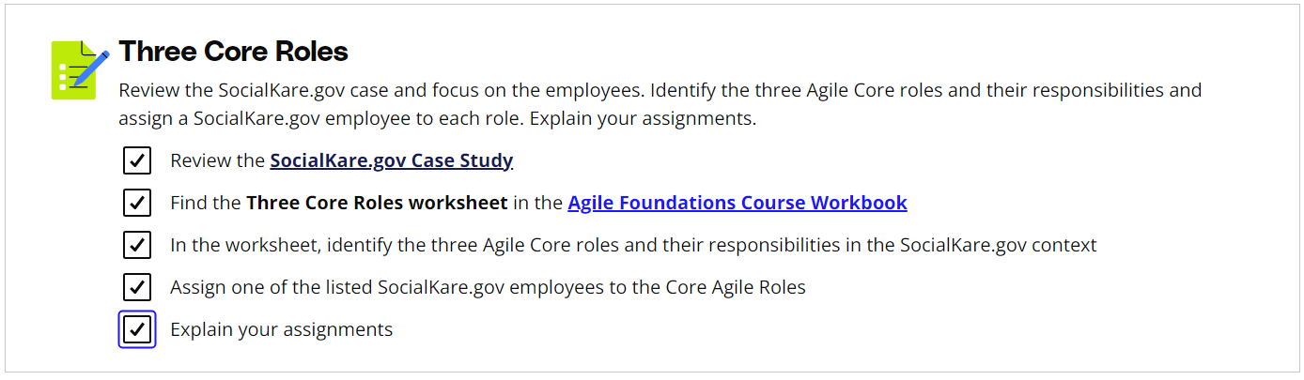

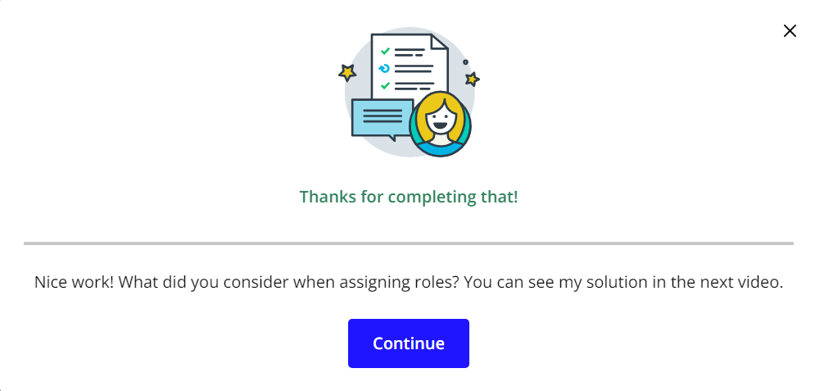

# Solution: Three Core Roles

## My Solution

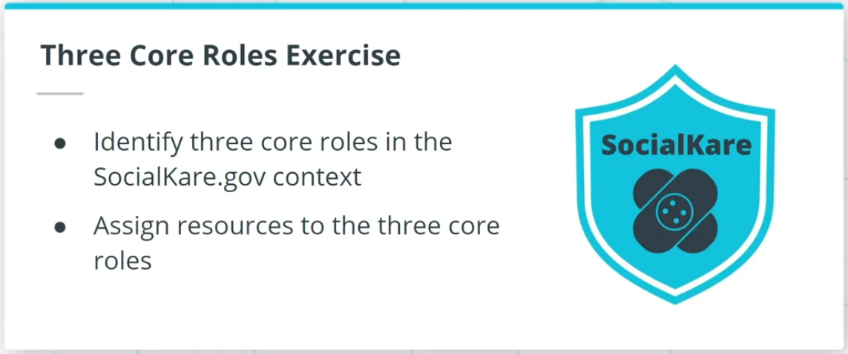

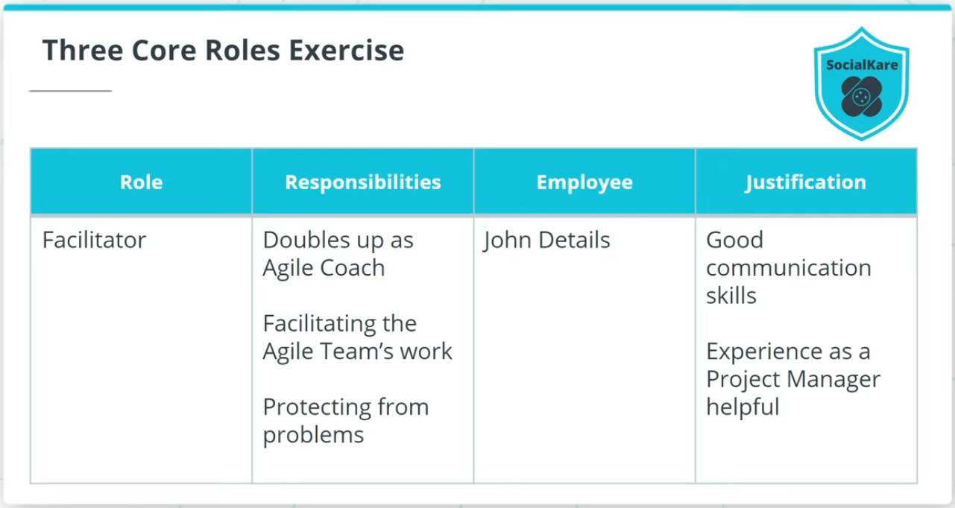

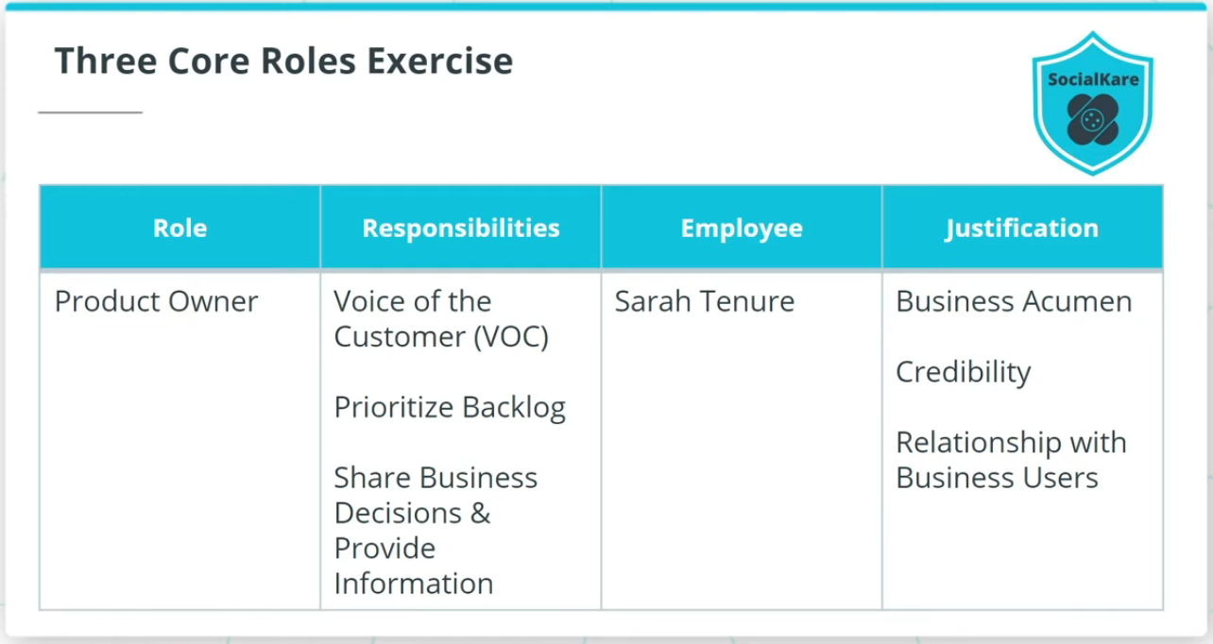

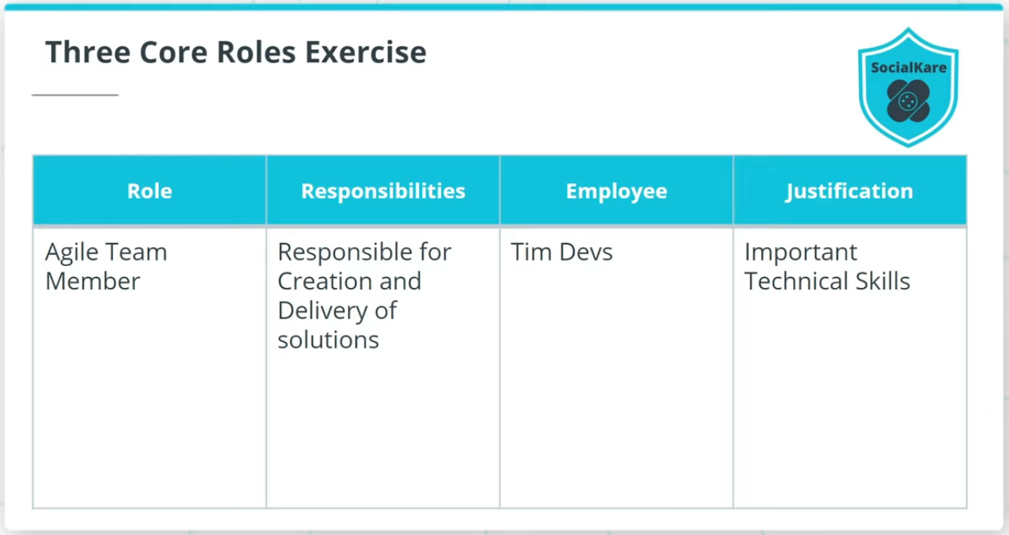

### **Identify the Three Agile Core Roles and Responsibilities for the SocialKare.gov Team**

* **Facilitator** - Can double up as an Agile Team coach or project lead at SocialKare.gov, is responsible for facilitating the Agile Team’s work, obtaining resources for it, and protecting it from problems. The recommended employee is ***John Details***.
* **Product Owner** - Represents the SocialKare.gov stakeholders and specifically is known as The Voice of the Customer (VOC); the one individual who is responsible for the prioritized work item list, called a Product Backlog; will be responsible for prioritizing the backlog, share business decisions in a timely manner, and for providing any requirements or functionality related information to the Agile Team in a timely manner. The recommended employee is ***Sarah Tenure***.
* **Agile Team Member** - Primarily includes developers who are responsible for the creation and delivery of a system; However, all other Agile team members will also be included in this category. This includes, but is not limited to, those who will conduct modeling, programming, testing, business analysis, front-end design, release activities, and others. The recommended employee is ***Tim Devs***.

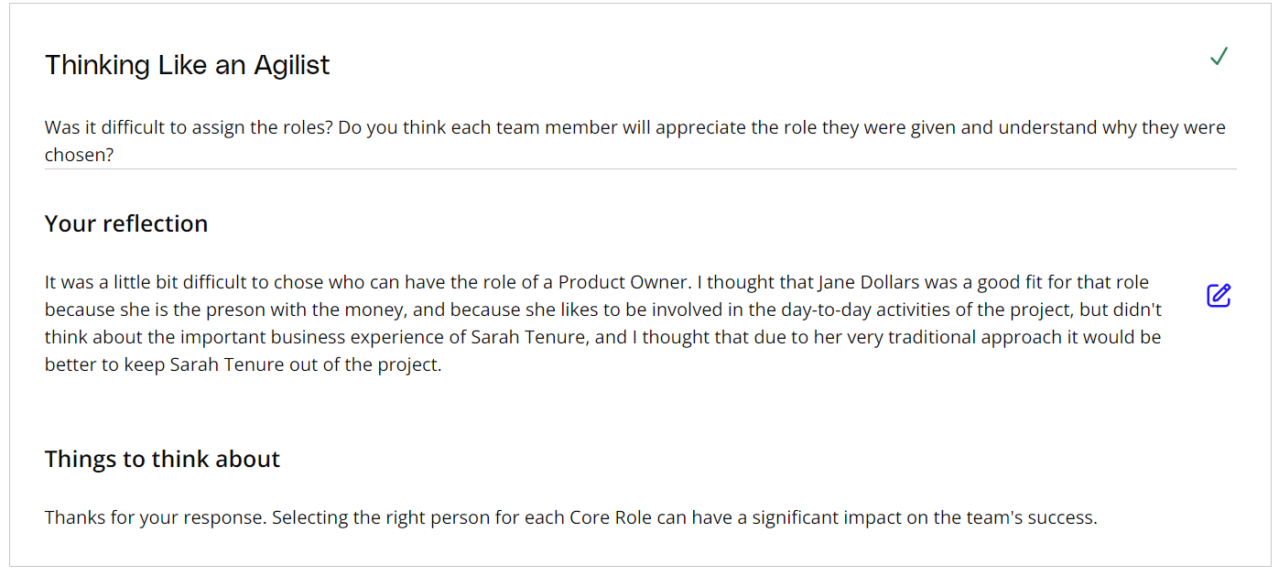

# High Performing Agile Teams

## What Is a High Performing Agile Team?

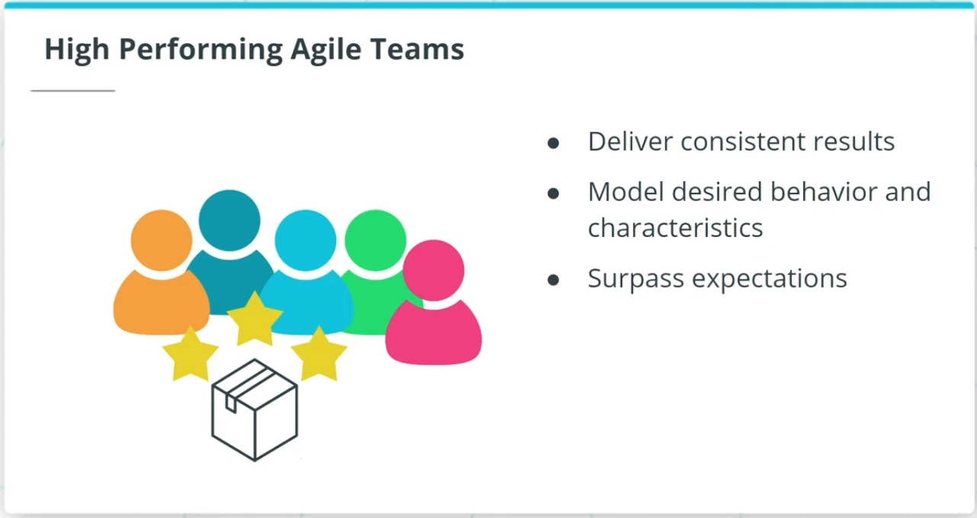

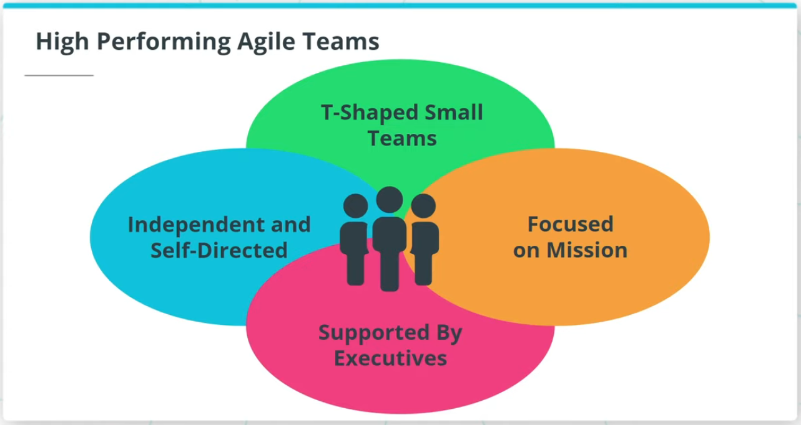

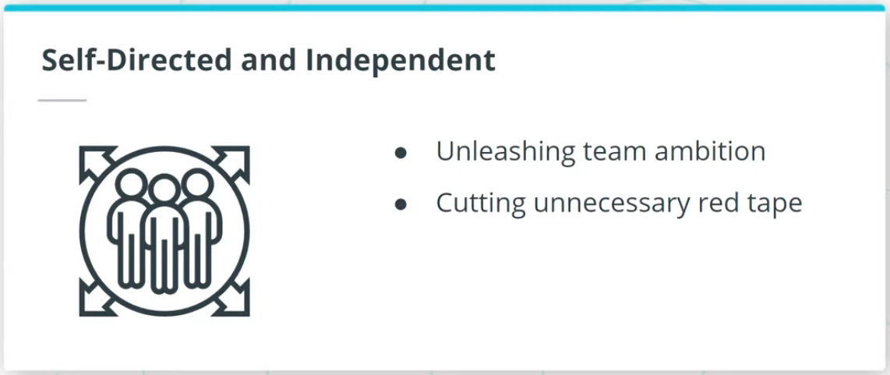

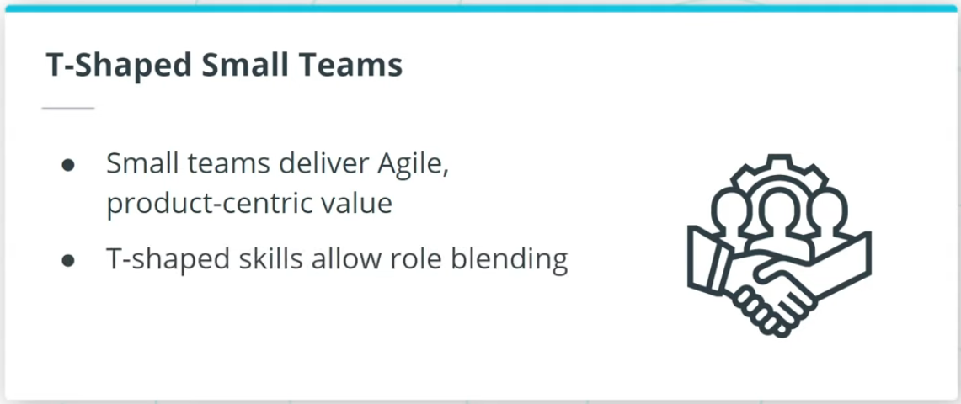

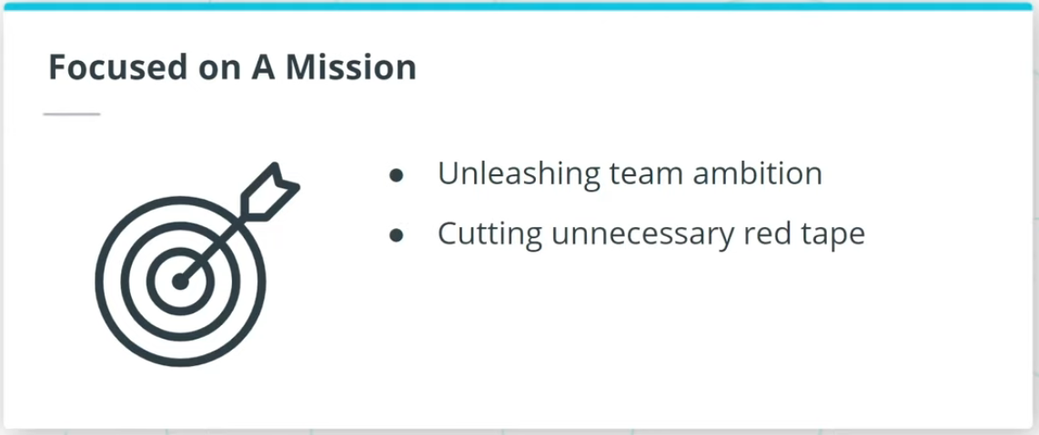

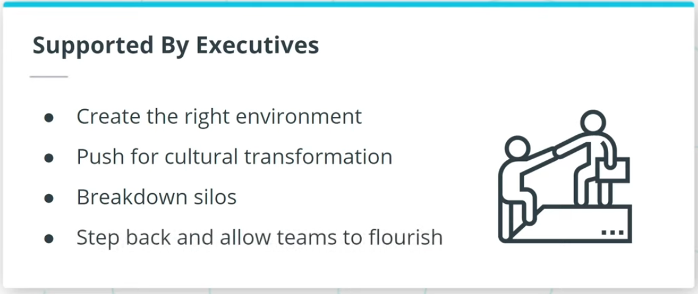

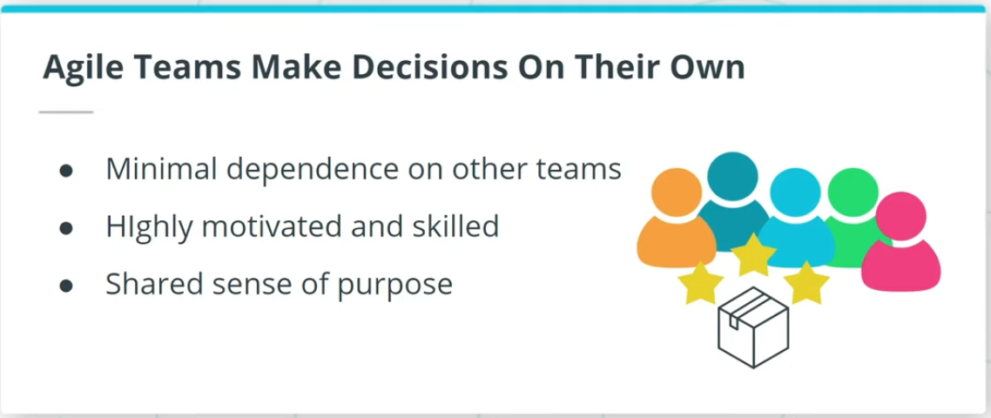

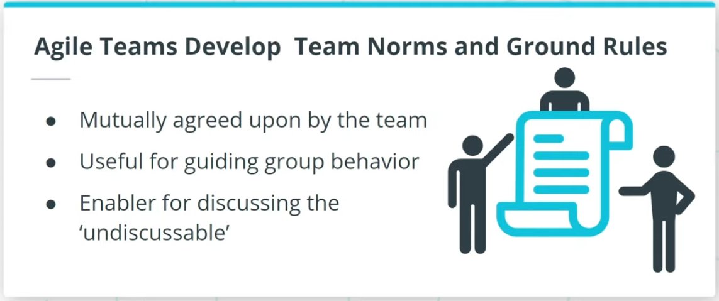

### **High Performing Agile Teams have the following in common.**

They are:

* Independent and self-directed
* Small, T-shaped teams
* Focused on the mission
* Supported by executives

Moreover, Agile Teams make decisions on their own. They also develop team norms and ground rules, which are useful for guiding group behavior towards a common purpose.

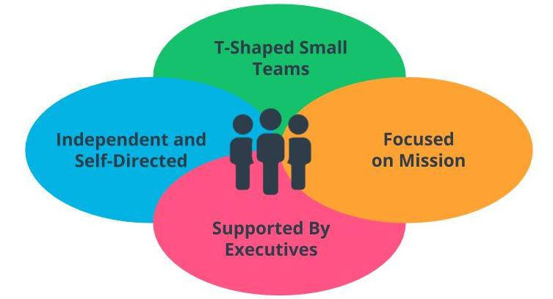

Attributes of High Performing Agile Teams

## Building High Performing Agile Teams

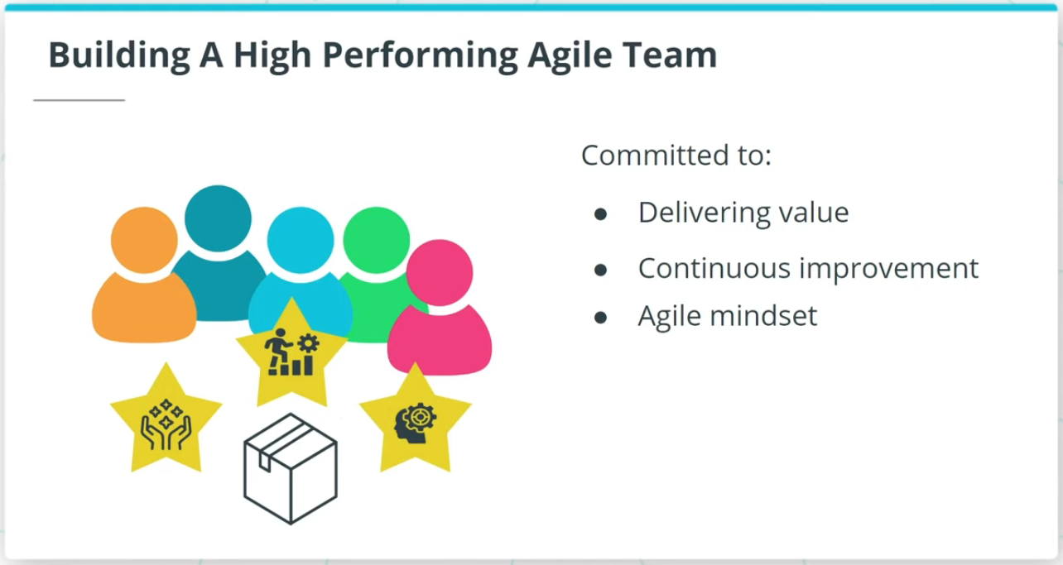

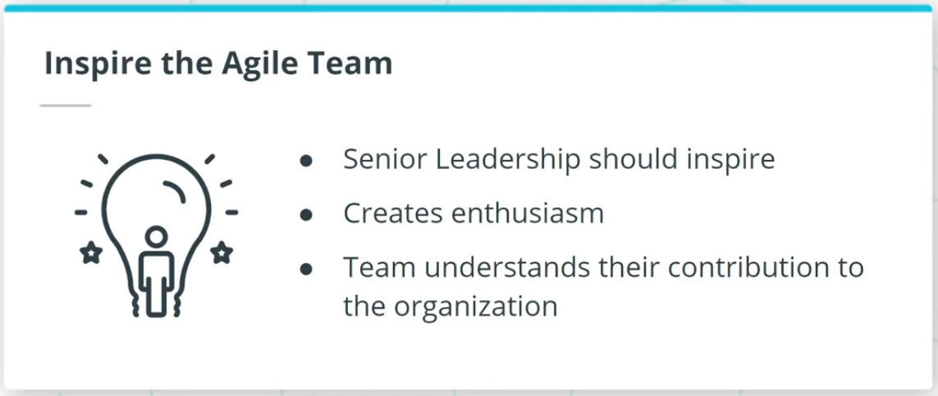

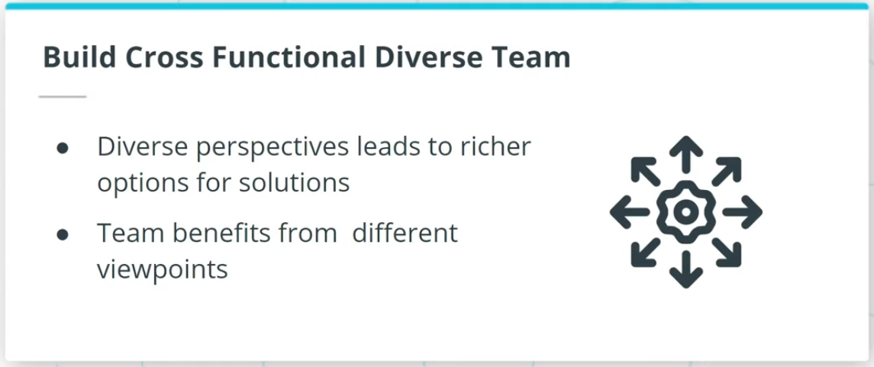

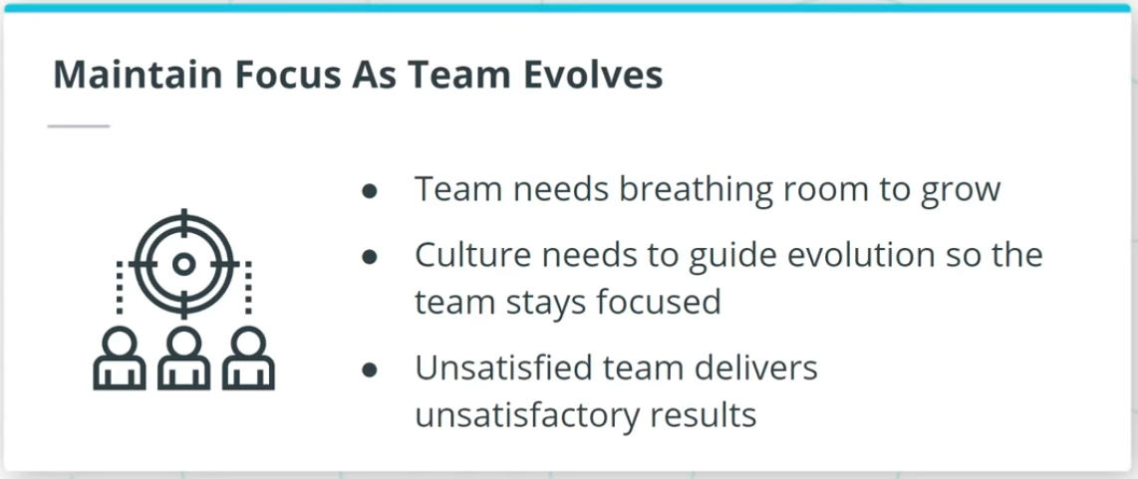

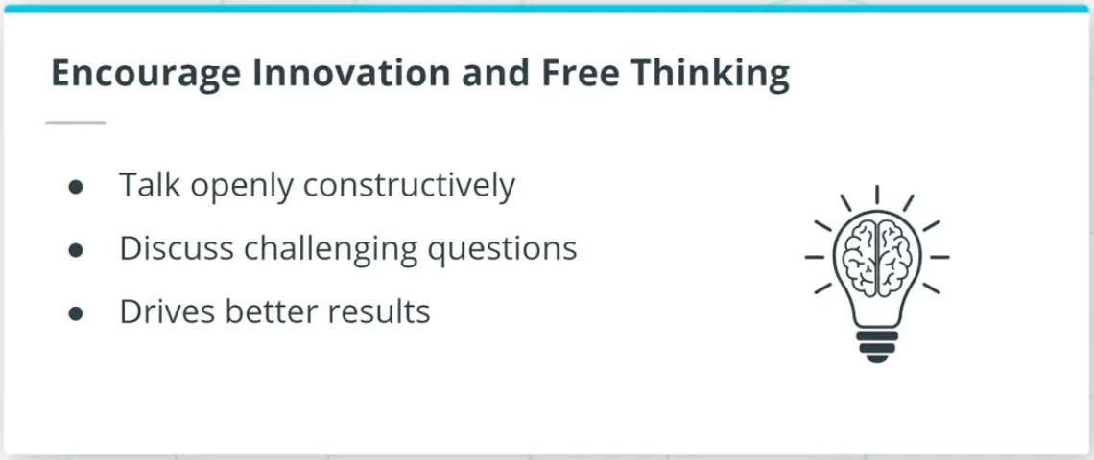

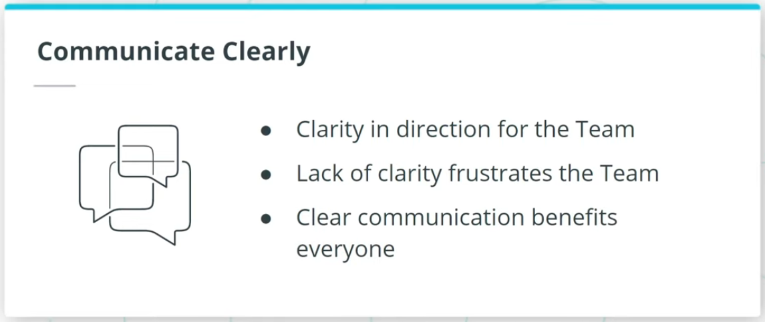

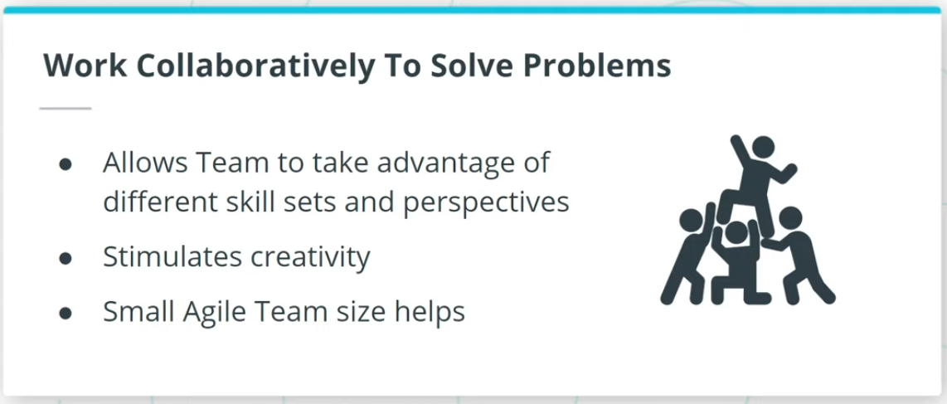

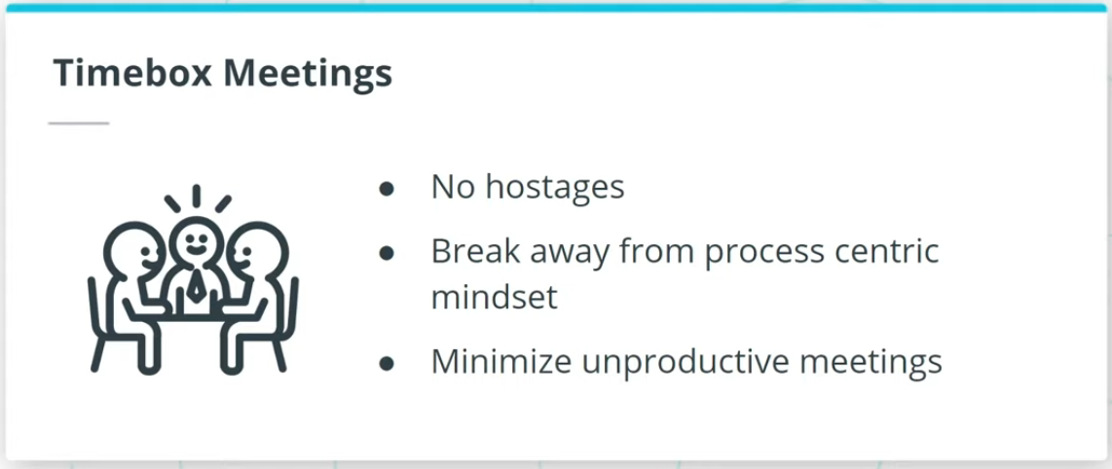

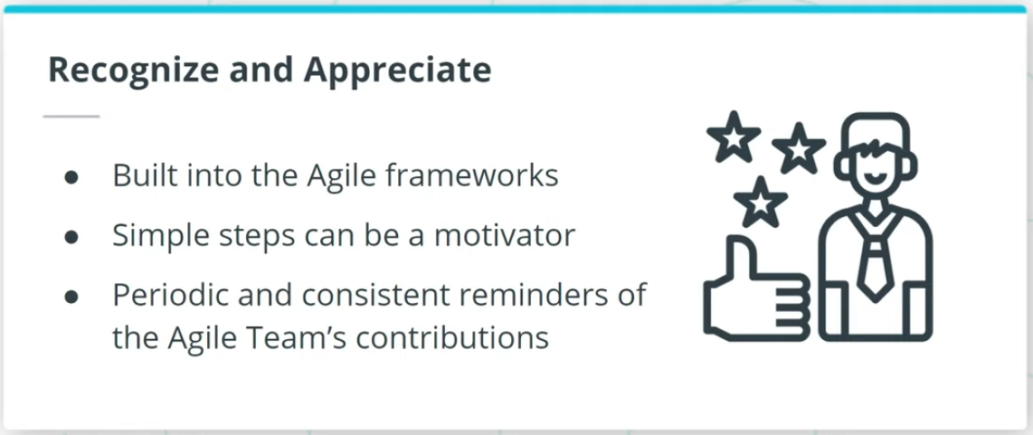

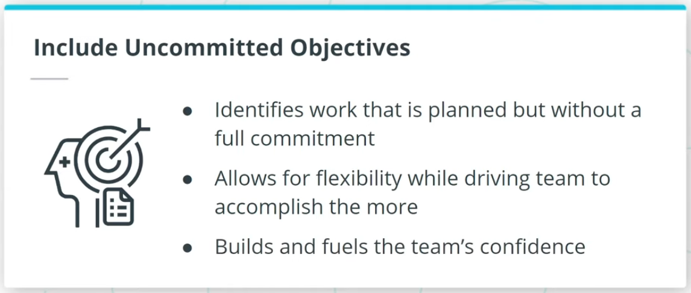

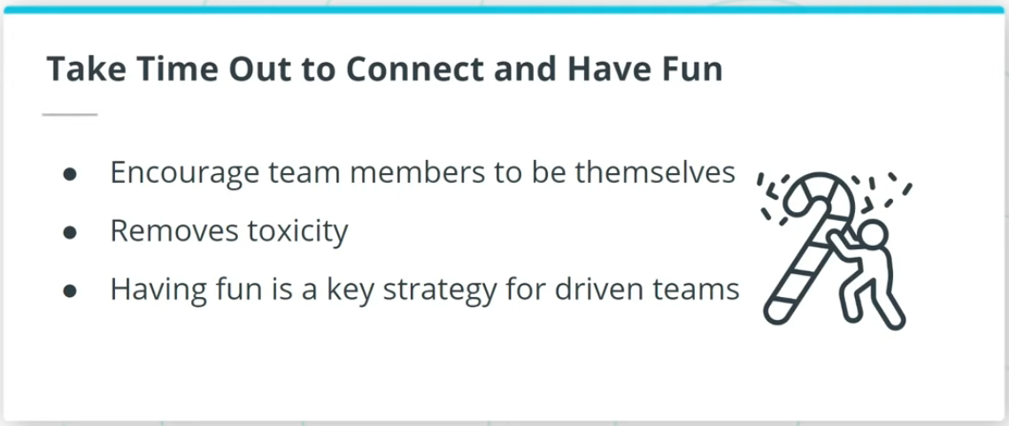

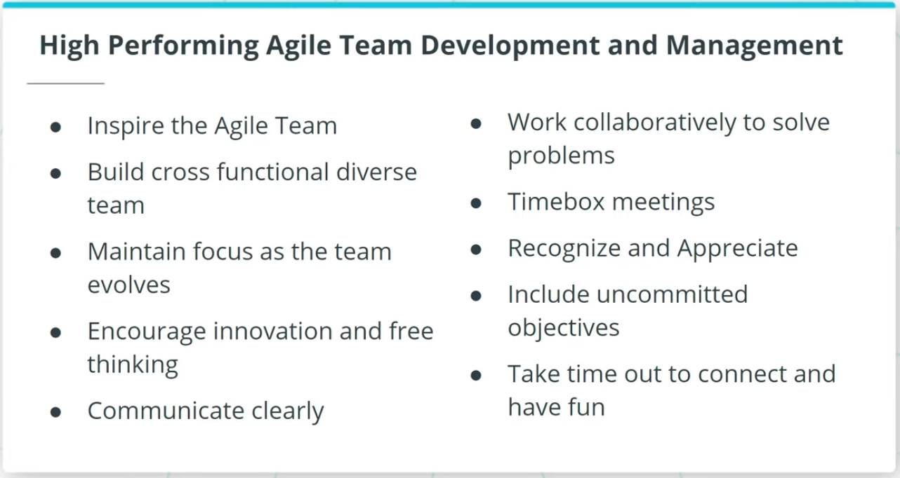

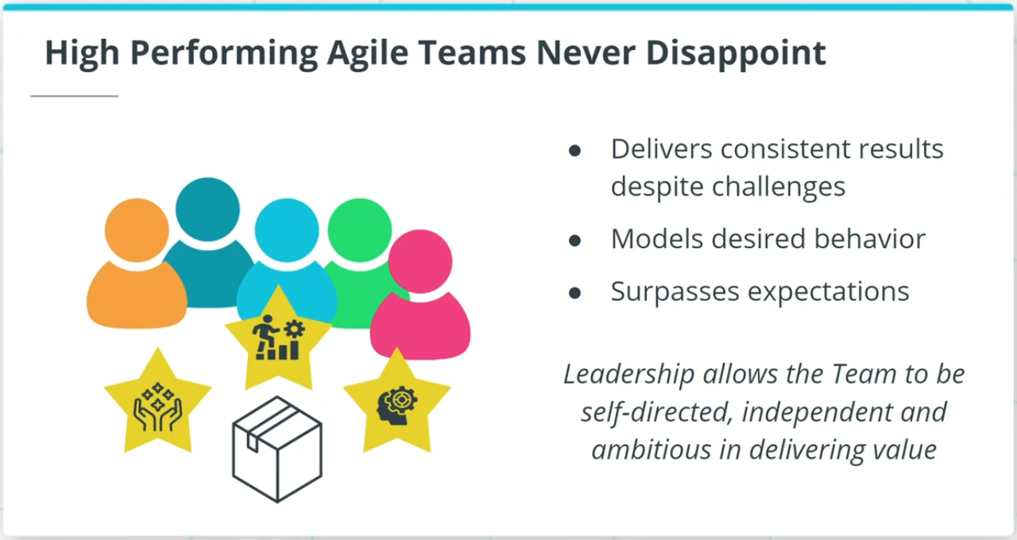

### **Building a High Performing Agile Team**

Let’s look at how we can build a high performing Agile Team:

* Inspire the Agile Team.
* Build a Cross-functional Diverse Team.
* Maintain Focus as Team Evolves.
* Encourage Innovation and Free Thinking.
* Communicate Clearly.
* Work Collaboratively to Solve Problems.
* Timebox Meetings.
* Recognize and Appreciate.
* Include Uncommitted Objectives.
* Take Time Out to Connect and Have Fun.

### **Building a High Performing Agile Team**

Let’s look at how we can build a high performing Agile Team:

* Inspire the Agile Team.
* Build a Cross-functional Diverse Team.
* Maintain Focus as Team Evolves.
* Encourage Innovation and Free Thinking.
* Communicate Clearly.
* Work Collaboratively to Solve Problems.
* Timebox Meetings.
* Recognize and Appreciate.
* Include Uncommitted Objectives.
* Take Time Out to Connect and Have Fun.

### **High Performing Agile Teams Never Disappoint**

According to the American author Dan Pink, a high performing team is given purpose, an opportunity to develop mastery, as well as autonomy in decisions. Such a high-performing Agile Team never disappoints. Such Agile Teams deliver phenomenal results consistently, regardless of the challenges they encounter. Senior leaders in an organization can turbocharge an Agile Team by enabling them to be self-directed and independent.

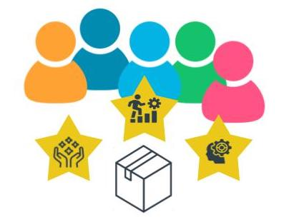

High Performing Agile Teams Never Disappoint

## Remote Agile Teams

In an increasingly interconnected global business landscape, High Performing Agile Teams have to identify issues and benefits related to organizing and managing remote Agile Teams. The recent COVID-19 pandemic has genuinely changed the landscape with remote Agile Teams being accepted as a valuable norm.

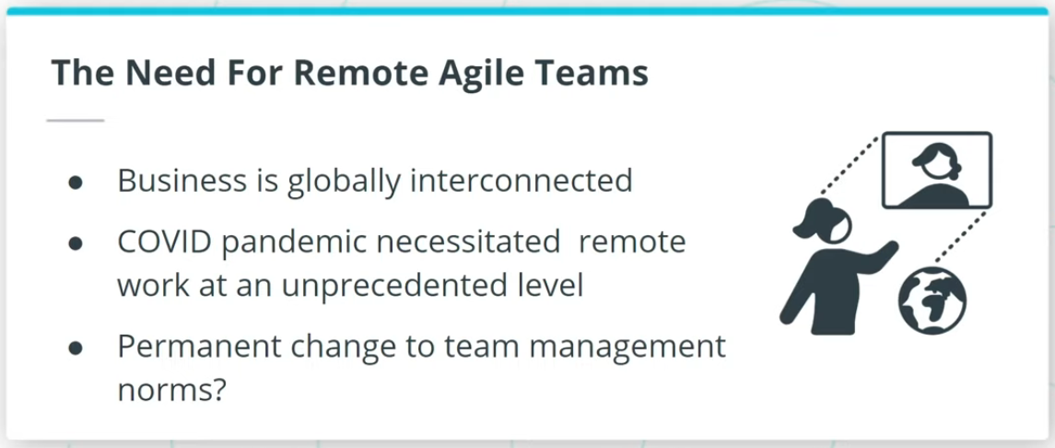

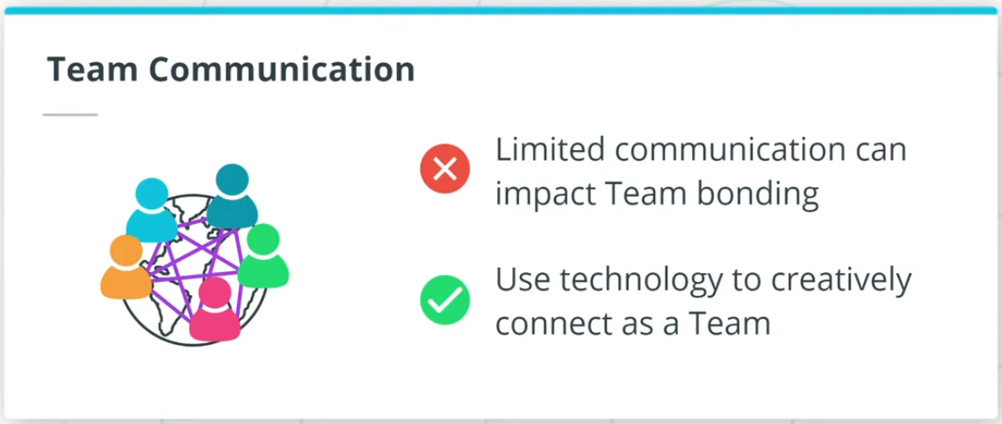

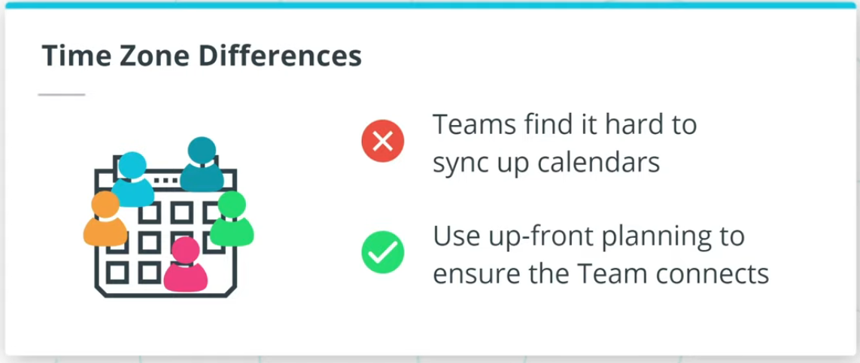

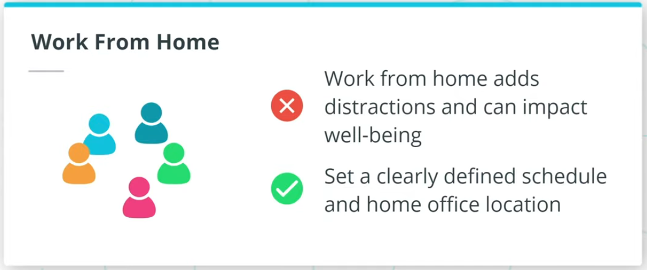

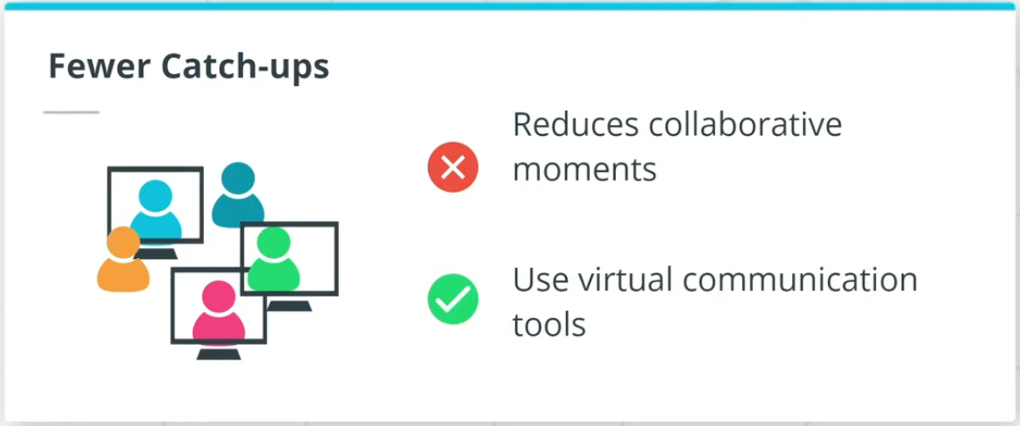

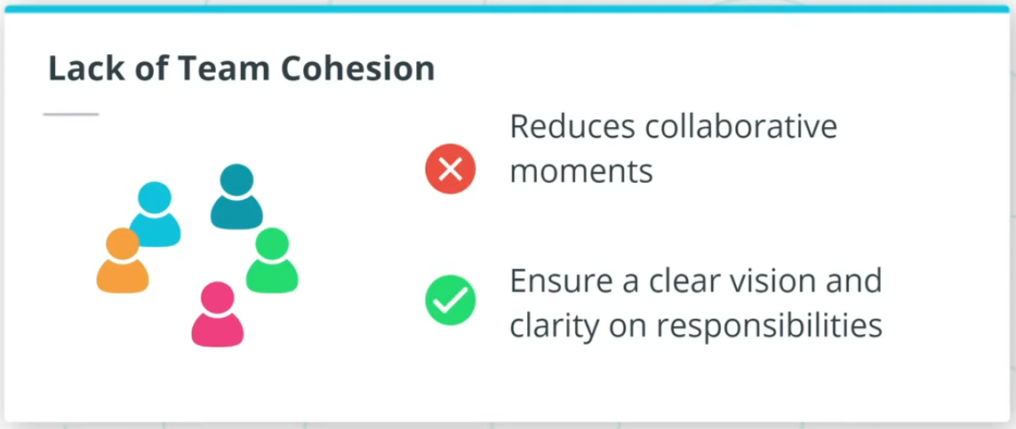

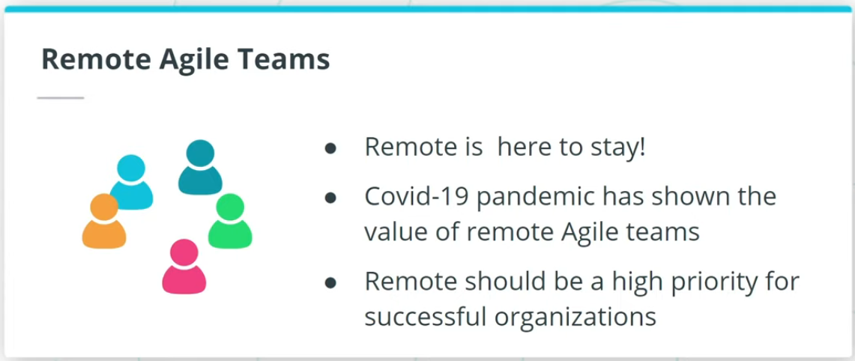

### **Implementing Remote Agile Teams**

Working with a remote Agile team successfully requires attention to the following:

* Team communication.
* Time Zone Differences.
* Work From Home Best Practices.
* Catch-Ups.
* Lack of Team Cohesion.

Remote Agile teams are definitely here to stay for the foreseeable future. The COVID-19 pandemic has resulted in a sea change in terms of the acceptance of the value of remote teams.

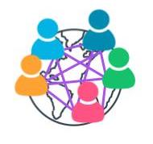

Remote Teams Are Here to Stay!

### **Additional Resources**

* Andy Fieldhouse. ***Getting Teamwork Right: The Key to Happy, Successful and Resilient Teams***. Rethink Press, 2020.  
  This book discusses in detail how to create highly functional teams.
* Daniel H. Pink, ***Drive: The Surprising Truth About What Motivates Us***, Riverhead Books, 2011.  
  In this book, Dan Pink thoroughly covers what drives skilled teams to deliver value.

# Quizzes: High Performing Agile Teams

## Thinking About High Performing Agile Teams

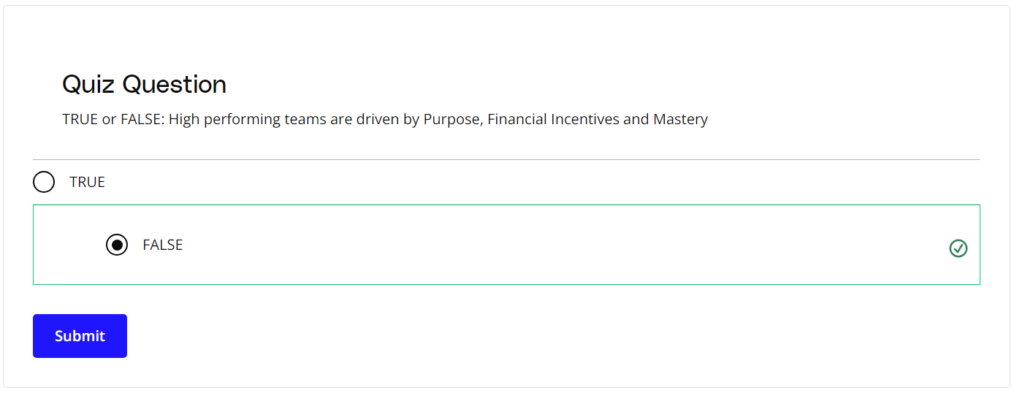

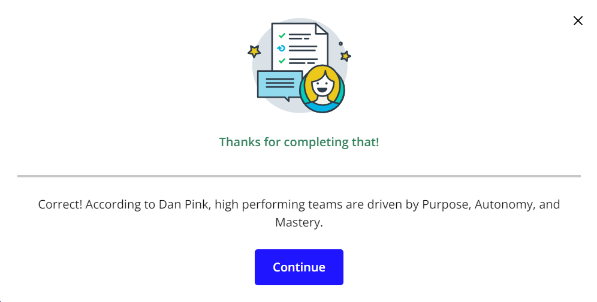

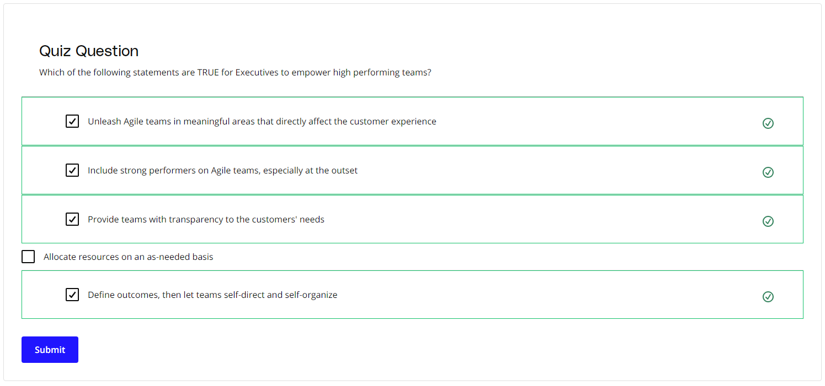

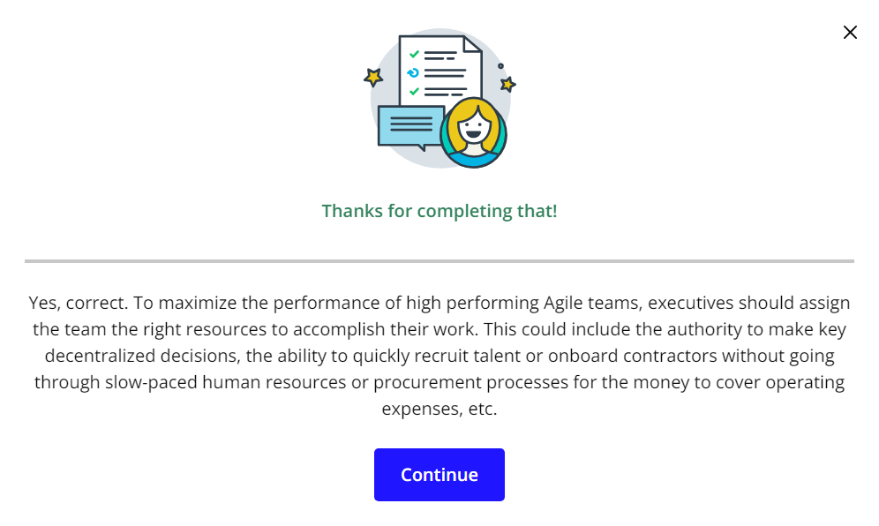

# Exercise: High Performing Agile Teams

### **High Performing Agile Teams**

High performing Agile Teams don't happen by accident. Team members need to be coached and nurtured to develop the skills and practices that make them more effective team members.

Review the [**SocialKare.gov Case Study**](https://video.udacity-data.com/topher/2020/September/5f5f6bc7_agnd-c1-foundations-of-agile-socialkare.gov-case-study/agnd-c1-foundations-of-agile-socialkare.gov-case-study.pdf). How can we help the SocialKare.gov Team evolve into a high performing Agile team? Select three team members and identify specific coaching recommendations to move to a more high performing model.



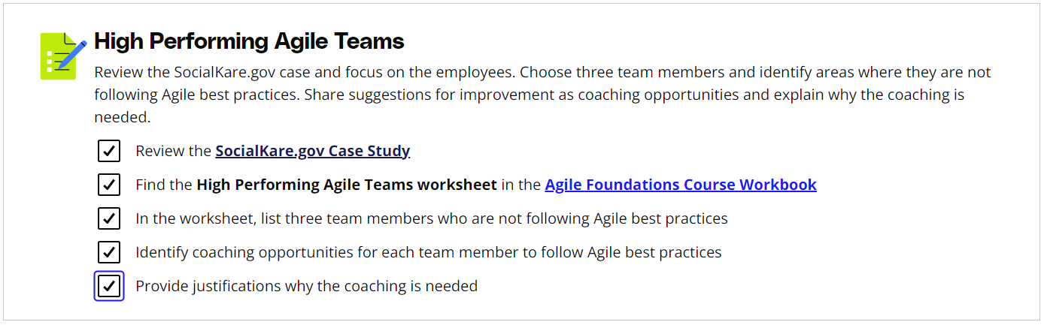

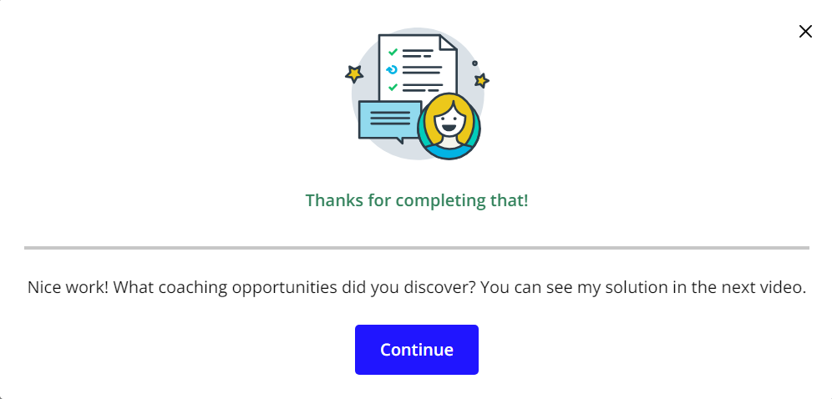

# Solution: High Performing Agile Teams

## My Solution

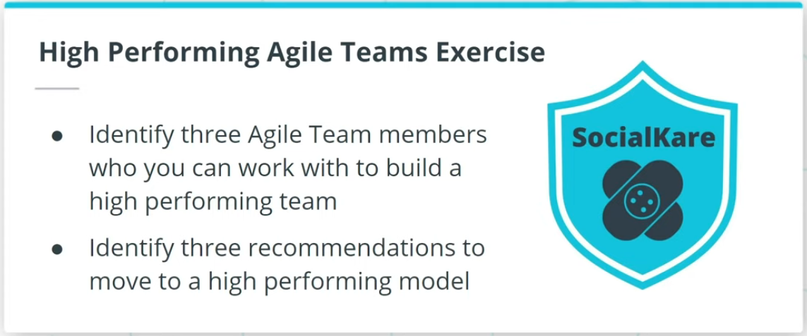

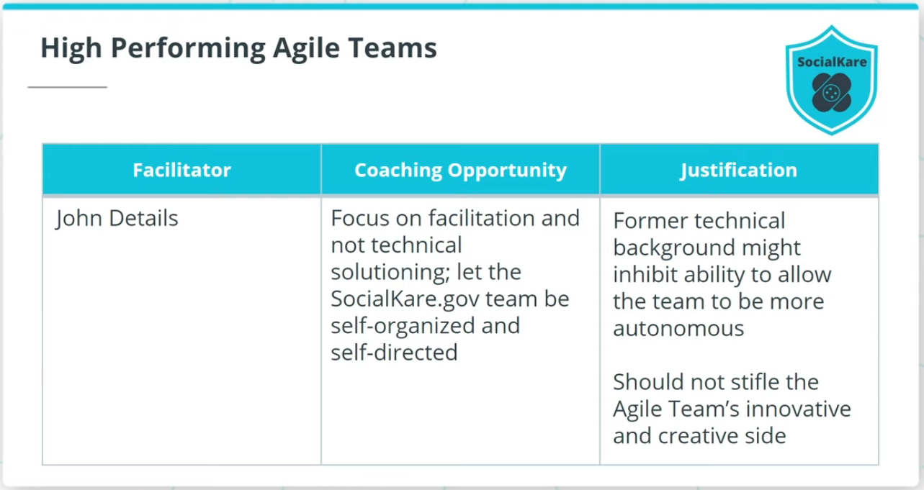

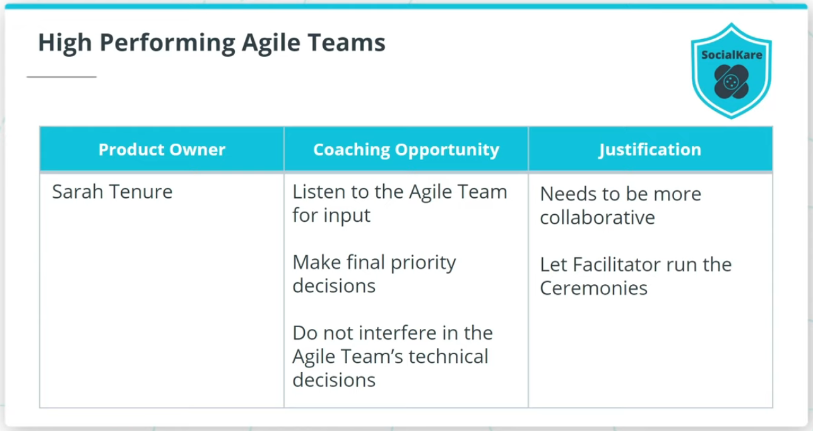

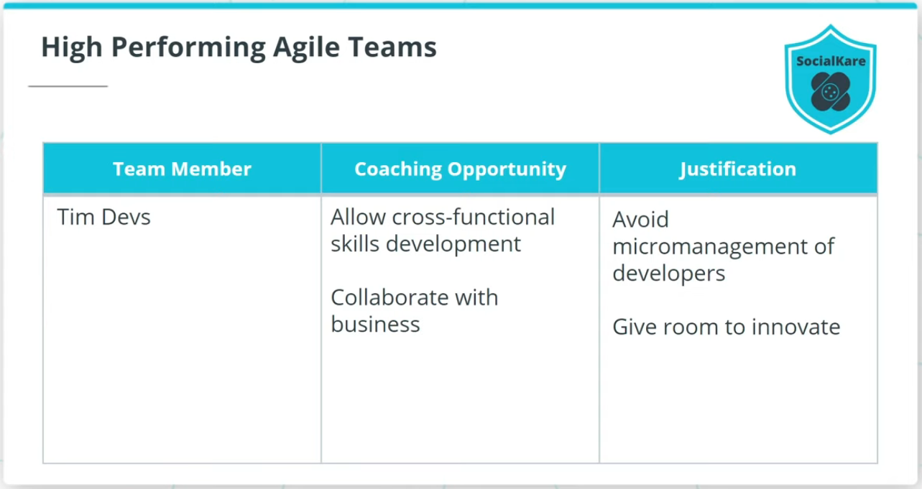

### **My Solution**

* John Details, as a Facilitator, should Focus on facilitation and not technical solutions; John needs to let the SocialKare.gov team be self-organized and self-directed.
* Sarah Tenure, the Product Owner, should Listen to the Agile Team for their input on priorities. Sarah should not interfere in the Agile Team’s technical decisions at SocialKare.gov.
* Tims Devs, an Agile Team member, should allow developers on the team to develop cross-functional skills, as well as work to collaborate with the business more proactively.

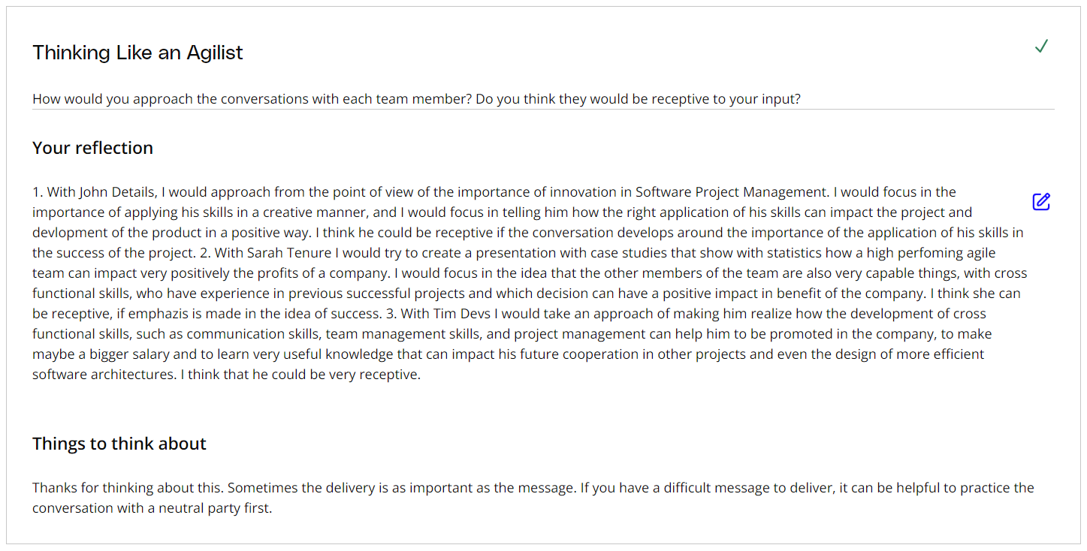

# Organizing an Optimal Agile Team and Non-Core Roles

## What Are Size, Structure, and Cross-functional Skills in an Agile Team?

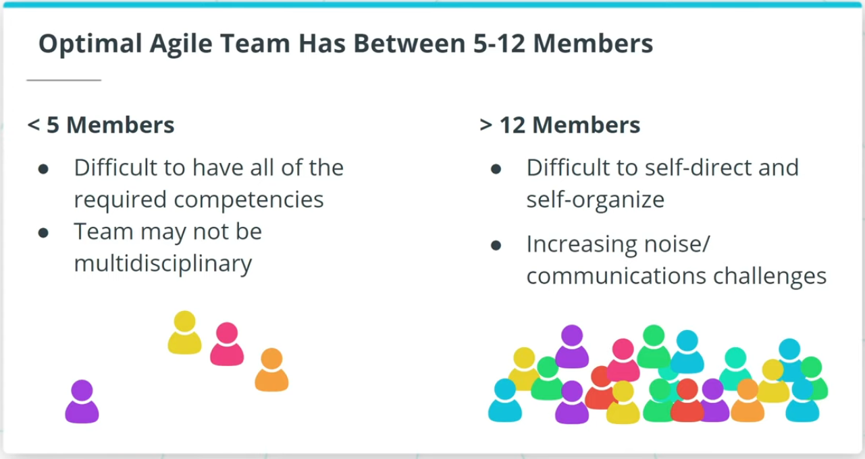

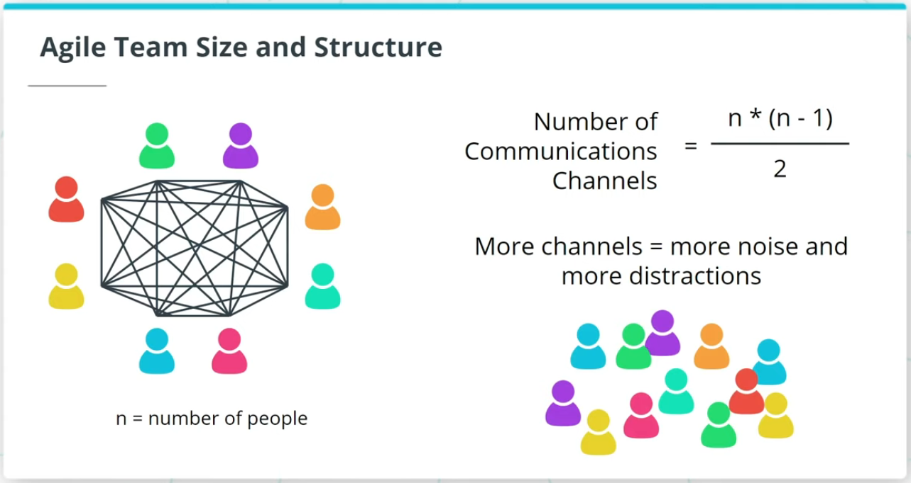

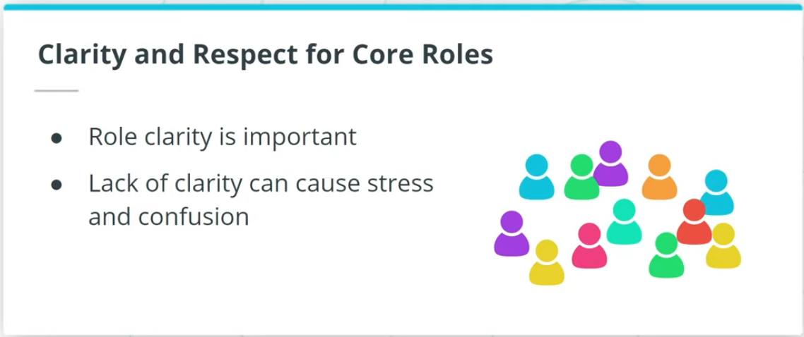

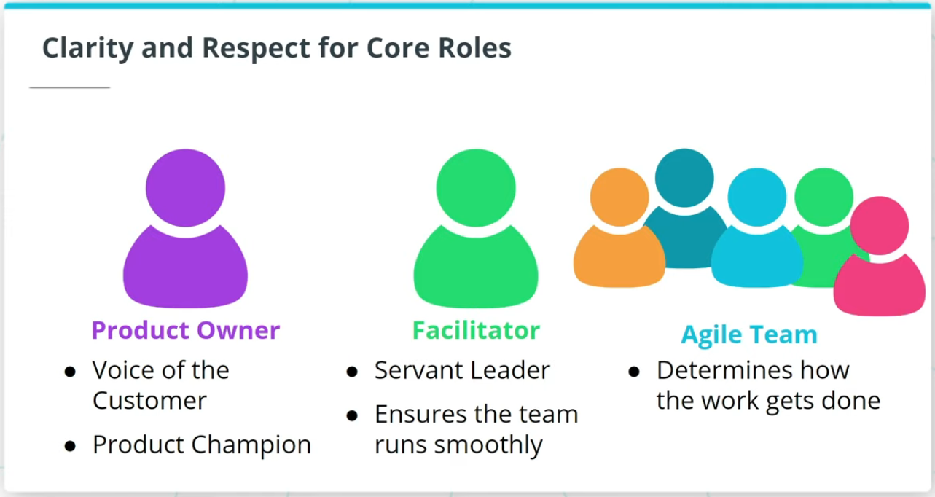

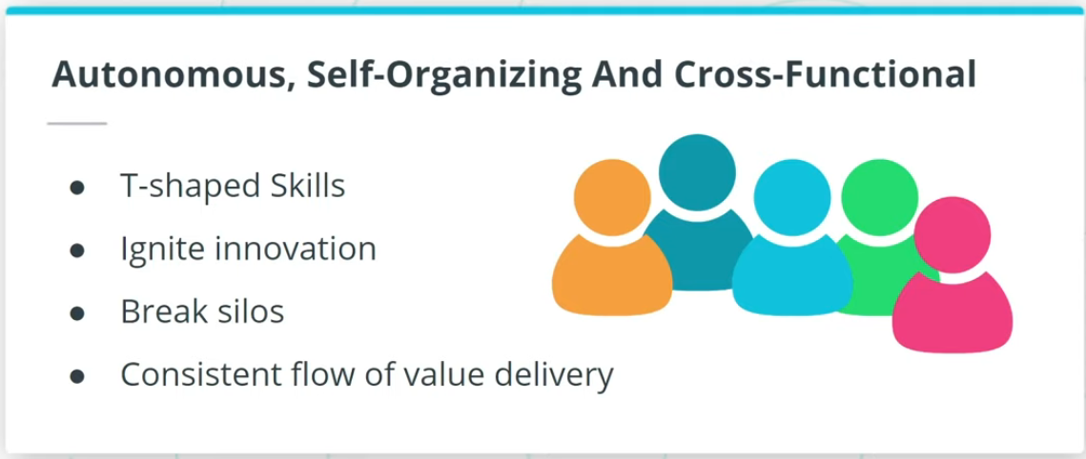

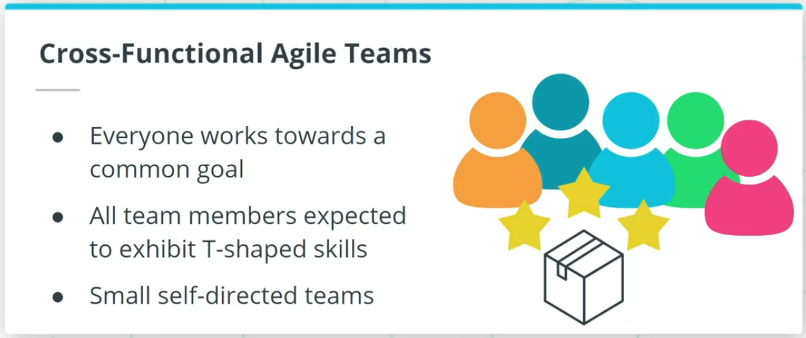

### **Optimal Agile Team has Between 5-12 Members**

* An Agile Team size of less than 5 would make it difficult to have all the competencies needed to do all the work within this one team since an Agile Team should be a cross-functional and multi-disciplinary unit tackling a common goal.
* An Agile Team larger than 12 skilled resources will make it difficult to self-direct and self-organize. As the number of team members increases, the number of communication channels also increases.

### **Clarity and Respect for Core Roles is Critical**

Role clarity is an important prerequisite.

Agilists have to remind Agile organizations of the core roles and their responsibilities:

* Product Owner- Voice of the Customer(VOC) and Product Champion
* Facilitator- A Servant Leader
* Agile Team- Responsible for determining how to get the work done that the PO has prioritized

Cross-functional Agile teams are best run as small self-directed teams of 5-12 skilled resources.

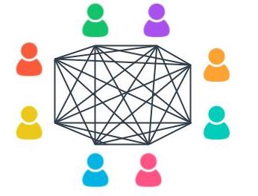

More Communication Channels = More Noise

## Non-Core Roles

While Non-Core Roles are not defined as mandatory in all Agile Frameworks, they can play a key role in the success of Agile Product Delivery.

* **Stakeholders** - Stakeholders can include Customers, Users, Sponsors, and others who have an interest in the product being worked on, but are not involved in the day-to-day development of the solution results.
* **Vendors and Strategic Suppliers** - Vendors and Strategic Partners provide products and services that are usually not within the core competencies of the organization or Agile Team.
* **Center of Excellence (CoE)** - Many organizations have a Center of Excellence focused on either Project or Product Delivery. A CoE often provides guidance on Governance and Reporting requirements to executives and regulators.
* **Enterprise Architect** - Reviews technical solutions to ensure they align with the overall organization's architecture.
* **Domain Subject Matter Expert** - Provides valuable support to the PO and Business Analyst on domain knowledge.

A successful Agile Team is typically both influenced and supported by several key Non-Core Roles.

### **Coaching Models**

#### Dreyfus Model of Skill Acquisition

The Dreyfus model presents a simple-to-understand framework for measuring an individual’s progress in any skill they are looking to acquire and gain expertise in. The five developmental stages identified in the Dreyfus Model for Skill Development are:

1. Novice
2. Advanced Beginner
3. Competent
4. Proficient
5. Expert

Read more about the Dreyfus Model of skill acquisition: [**The Five-Stage Model of Adult Skill Acquisition(opens in a new tab)**](http://www.bumc.bu.edu/facdev-medicine/files/2012/03/Dreyfus-skill-level.pdf)

#### Shu Ha Ri

Shu Ha Ri has its origins in Japanese Martial Arts. It is presented by experts as a way of thinking when learning a new skill. Alistair Cockburn is credited with introducing it in the Agile world when it comes to acquiring Agile skills for product development. There are three stages in Shu Ha Ri’s knowledge acquisition model:

* **Shu**: Here the Agile team member mimics and follows the teachings of an expert.
* **Ha**: At the Ha stage, team members start to experiment and begin to dig deeper into the theory that is driving the expert’s teachings
* **Ri**: When someone reaches the Ri stage, they have directly experimented and experienced how teaching is beneficial to the Agile team’s maturity. This allows them to get creative and adapt to their unique circumstances and organizational context.

You can read more about Shu Ha Ri here:

* [**Shu Ha Ri: An Agile Adoption Pattern(opens in a new tab)**](https://www.accenture.com/us-en/blogs/software-engineering-blog/shuhari-agile-adoption-pattern)
* [**Becoming agile with ShuHaRi(opens in a new tab)**](https://www.pmi.org/learning/library/becoming-agile-with-shuhari-9649)

### **New Terms**

* **Center of Excellence (COE)**: A unit comprised of seasoned experts in the organization that provide the Agile team support, best practices, guidance, and perhaps even training on Agile practices
* **Enterprise Architect (EA)**: A team member who ensures IT and the business units are aligned

# Quizzes: Organizing an Agile Team

## Thinking About Organizing an Agile Team

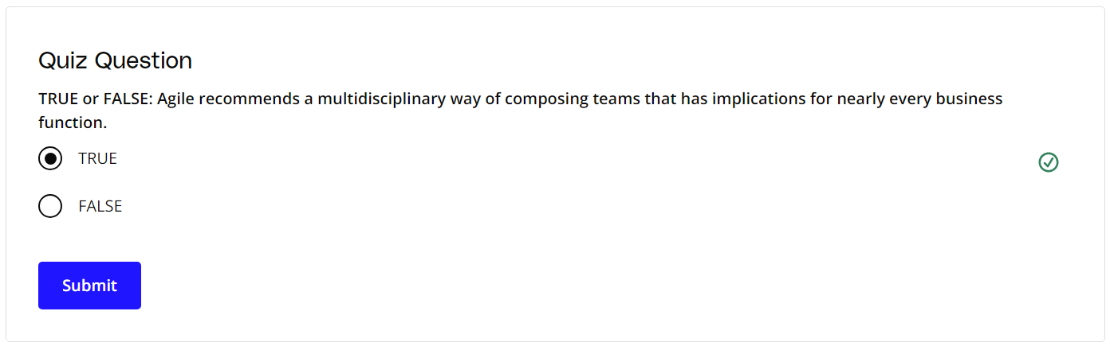

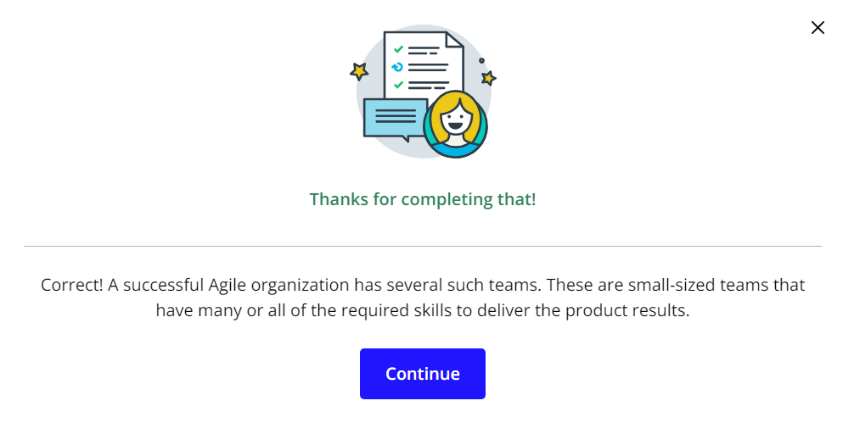

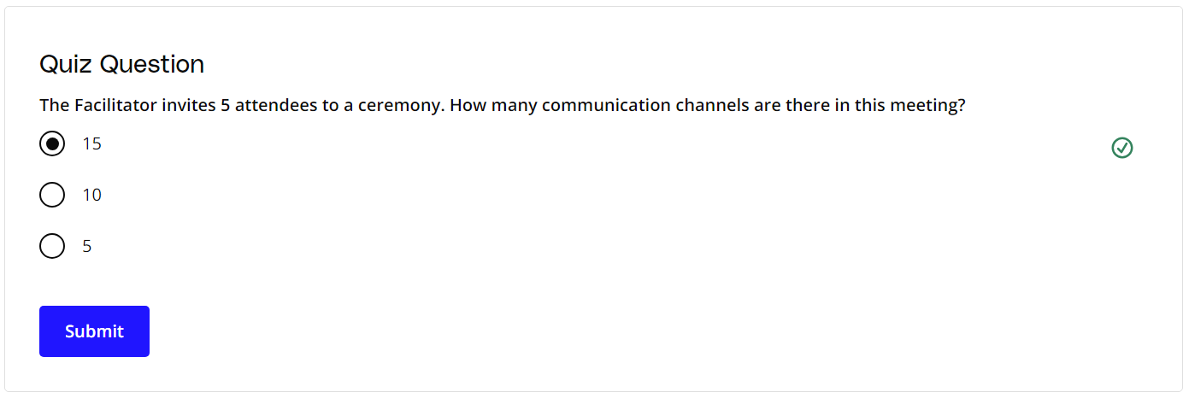

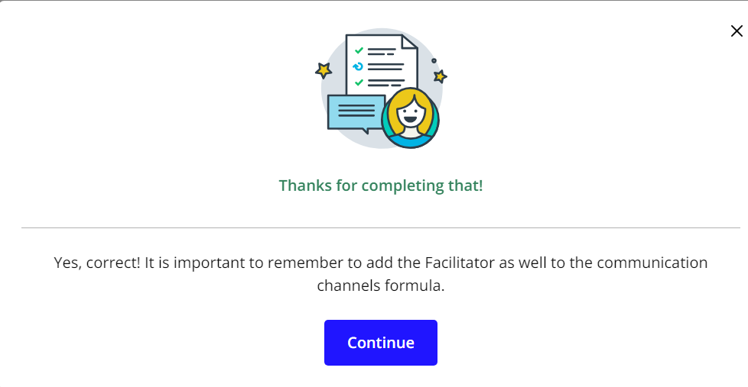

# Exercise: Non-Core Roles On An Agile Team

### **Identifying Non-Core Roles at SocialKare.gov**

Agile Teams have non-core roles too! Review the [**SocialKare.gov Case Study(opens in a new tab)**](https://video.udacity-data.com/topher/2020/September/5f5f6bc7_agnd-c1-foundations-of-agile-socialkare.gov-case-study/agnd-c1-foundations-of-agile-socialkare.gov-case-study.pdf) and identify some of the non-core roles that make sense for the SocialKare.gov team. Explain why those roles are necessary for the SocialKare.gov team.



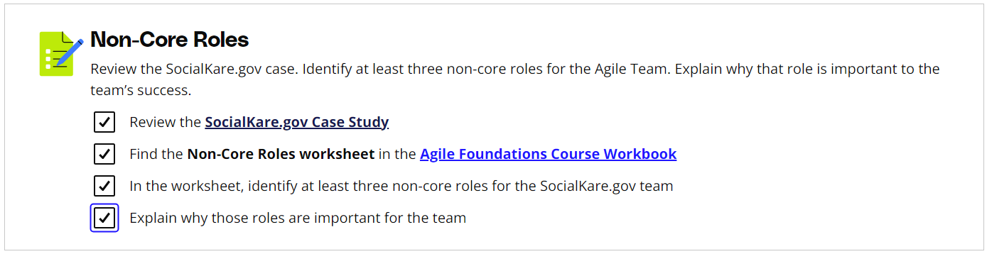

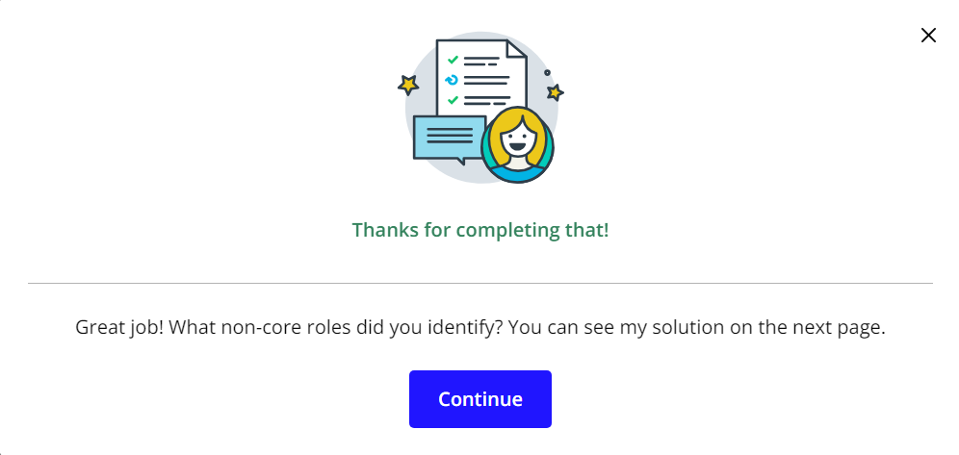

# Solution: Non-Core Roles On An Agile Team

## My Solution

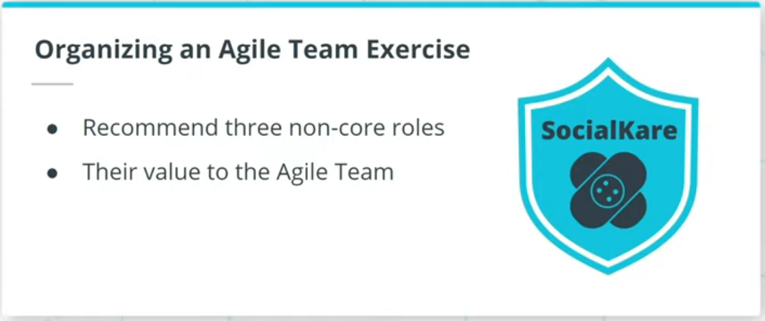

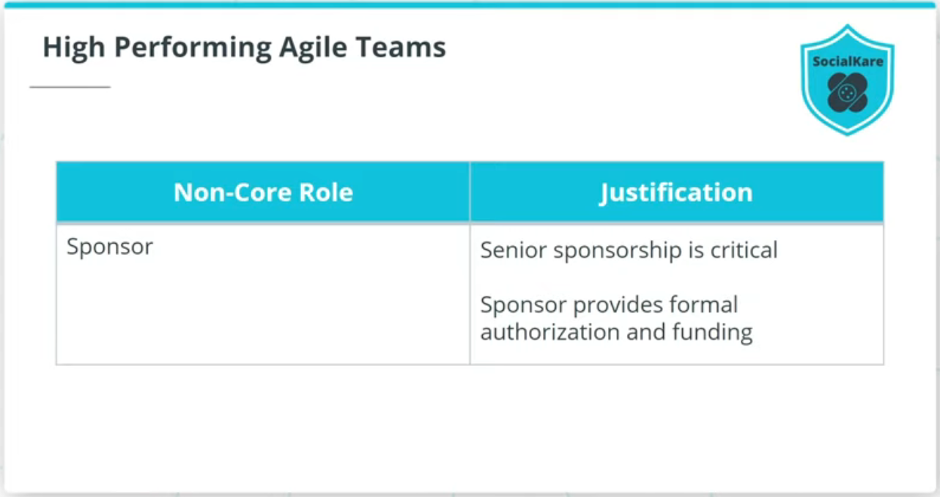

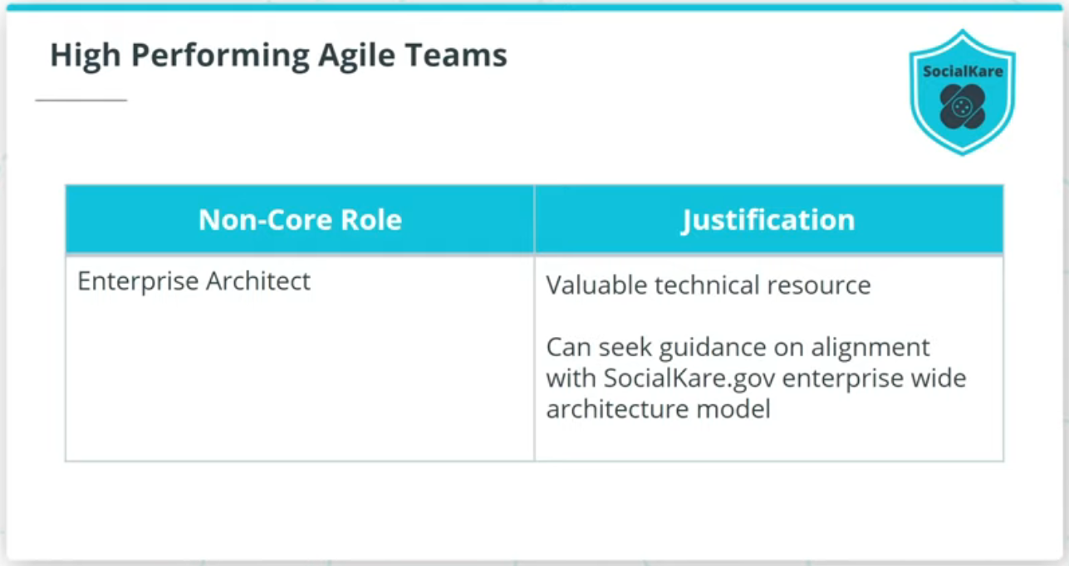

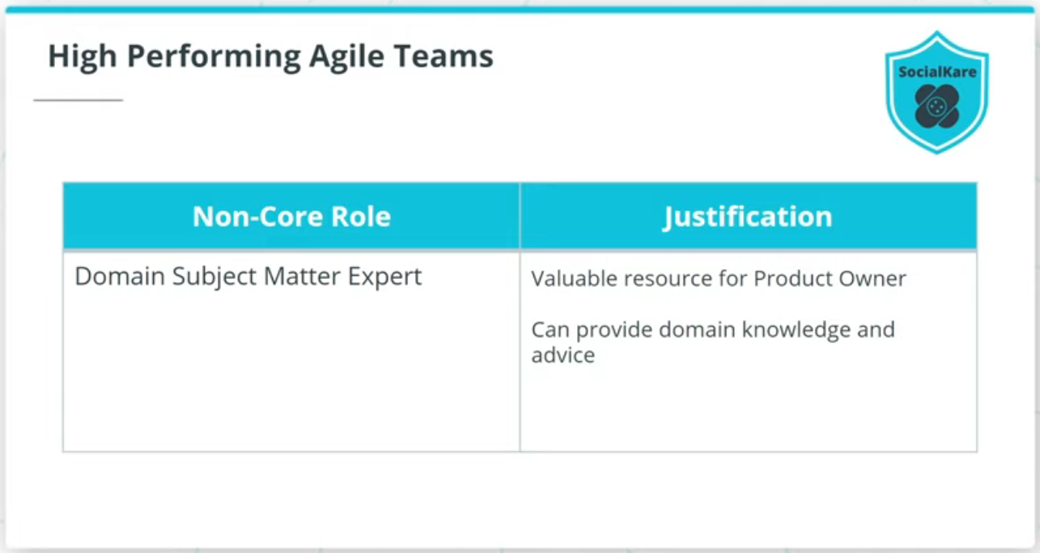

### **Recommend Three Non-Core Roles**

* **Sponsor** - Senior sponsorship is critical to the success of any Agile product delivery.
* **Enterprise Architect** - An Enterprise Architect will be a valuable resource for the technical team members to seek guidance on to ensure whatever they develop is in alignment with SocialKare.gov's enterprise-wide architecture model.
* **Domain Subject Matter Expertise** - This individual can be very beneficial for the Product Owner, as well as Business Analyst. This person can be called upon as needed to provide Domain knowledge and advice.

# Agile Governance

## What Is Agile Governance?

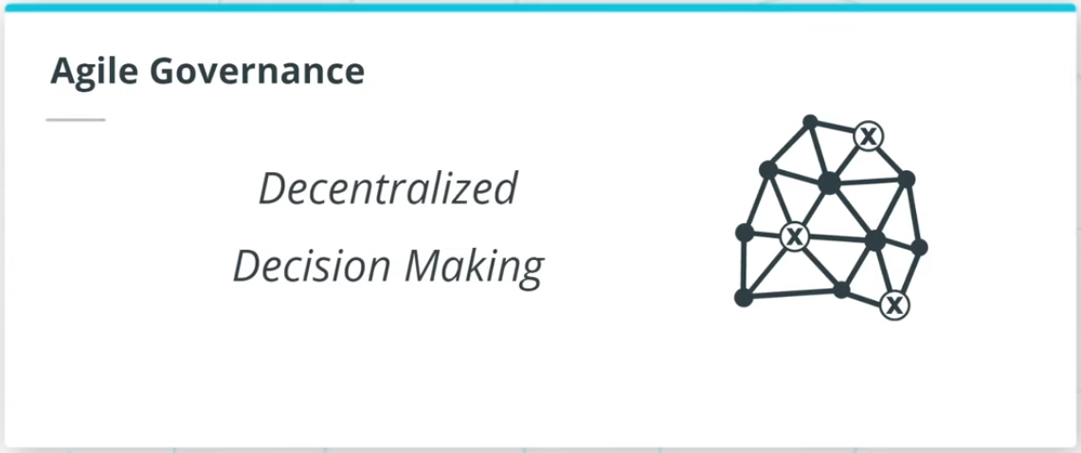

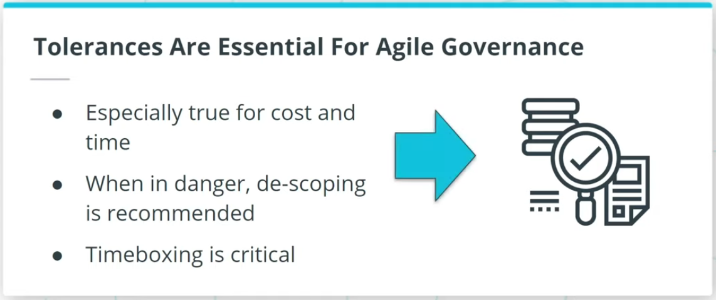

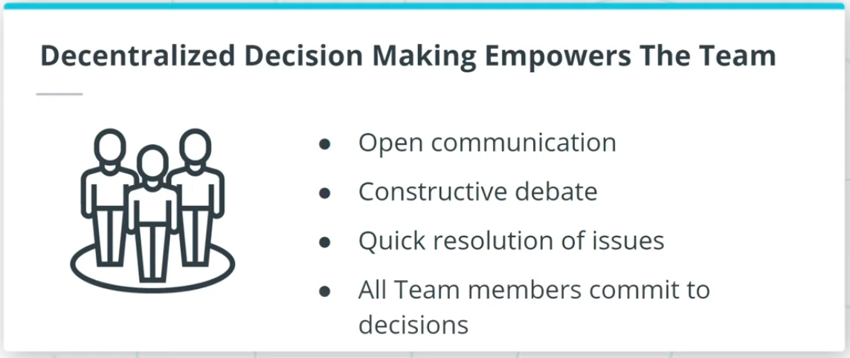

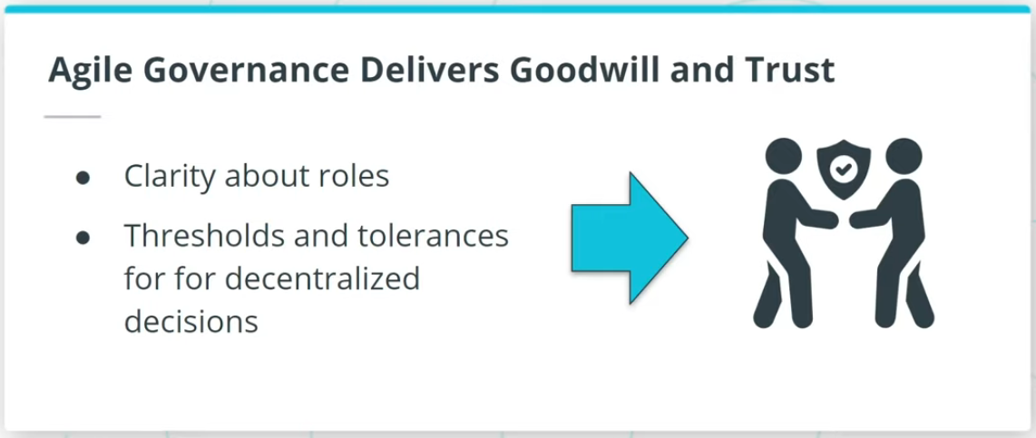

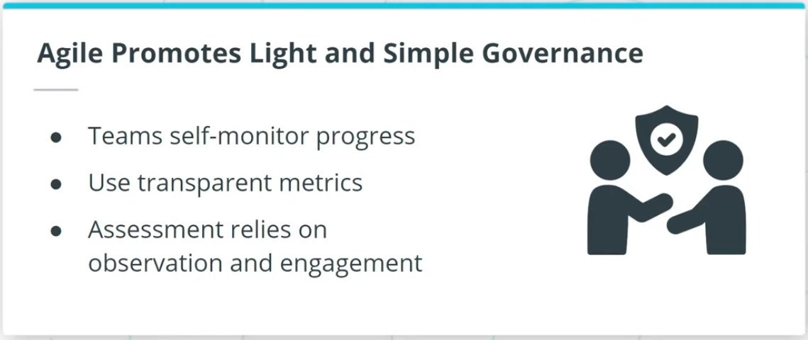

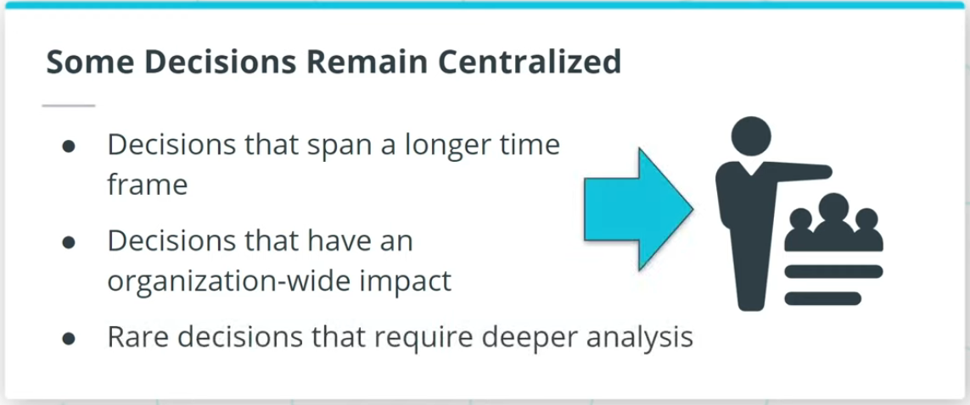

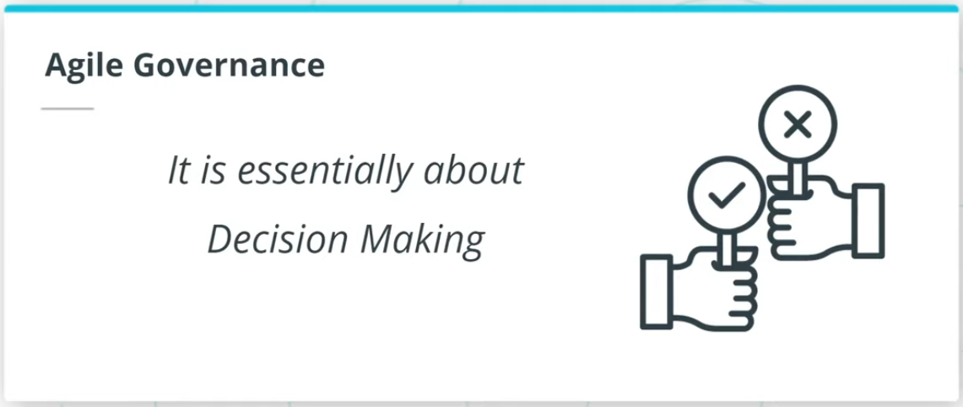

### **Effective Agile Governance is about Making Decisions**

In order to enable effective Agile governance, the following needs to be kept in mind:

* Tolerances Are Essential For Agile Governance.
* Decentralized Decision Making Empowers The Team.
* Agile Governance Delivers Goodwill and Trust.
* Agile Promotes Light and Simple Governance.
* Strategic and Long-Term Decisions Remain Centralized.

Effective Agile governance ensures decisions are made in a simpler and lighter manner per the Agile Manifesto’s guidance to keep things simple.

### **Additional Resources**

* [**Governing Agile Teams(opens in a new tab)**](https://www.pmi.org/disciplined-agile/people/governing-agile-teams) - This article discusses various facets of what is and what is not considered Agile governance.
* [**Organizing: Centralization and Decentralization(opens in a new tab)**](https://www.toppr.com/guides/business-management-and-entrepreneurship/organizing/centralization-and-decentralization/) - This article compares the advantages of centralized and decentralized organization and describes the factors for determining the degree of decentralization decision-making.

# Quizzes: Agile Governance

## Thinking About Agile Governance

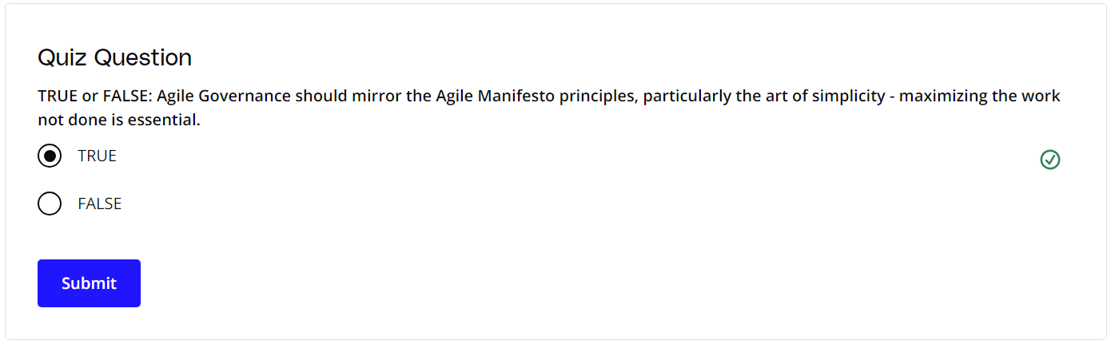

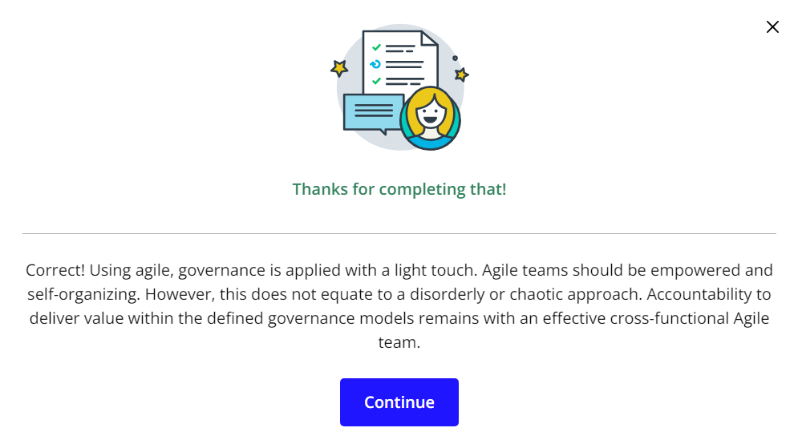

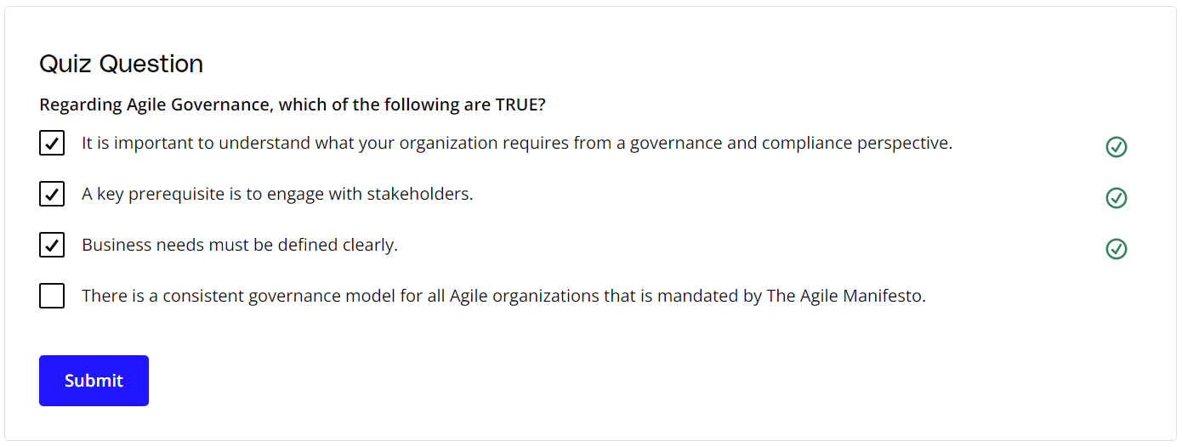

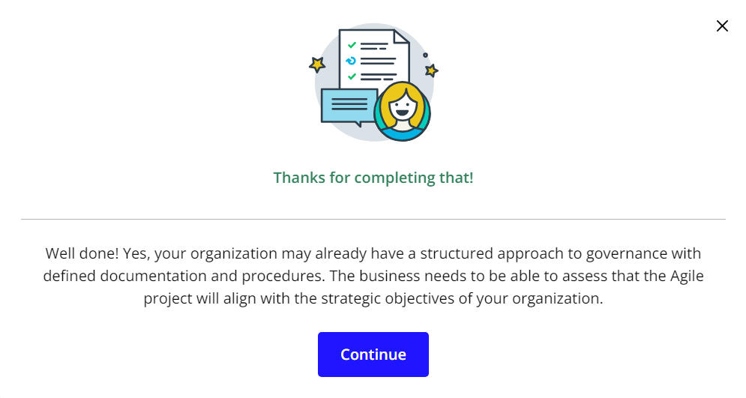

# Exercise: Centralized vs Decentralized Decisions

## Applying Agile Governance at SocialKare.gov

As we learned, while decentralized decision-making is encouraged in Agile, some decisions need to remain centralized. Review the [**SocialKare.gov Case Study(opens in a new tab)**](https://video.udacity-data.com/topher/2020/September/5f5f6bc7_agnd-c1-foundations-of-agile-socialkare.gov-case-study/agnd-c1-foundations-of-agile-socialkare.gov-case-study.pdf) and identify the types of decisions that need to be made. What are the characteristics of decisions that can be decentralized? And what are the characteristics of decisions that should be centralized?



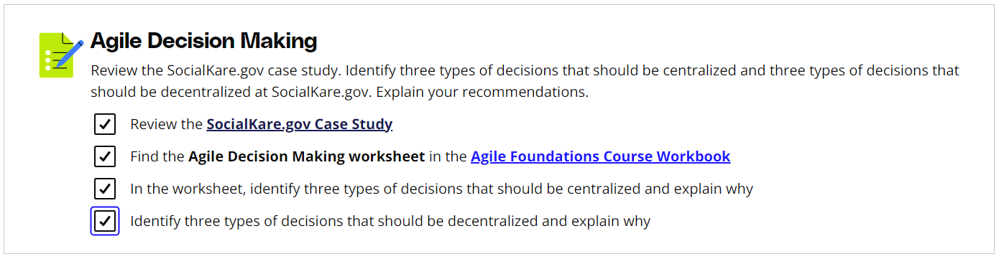

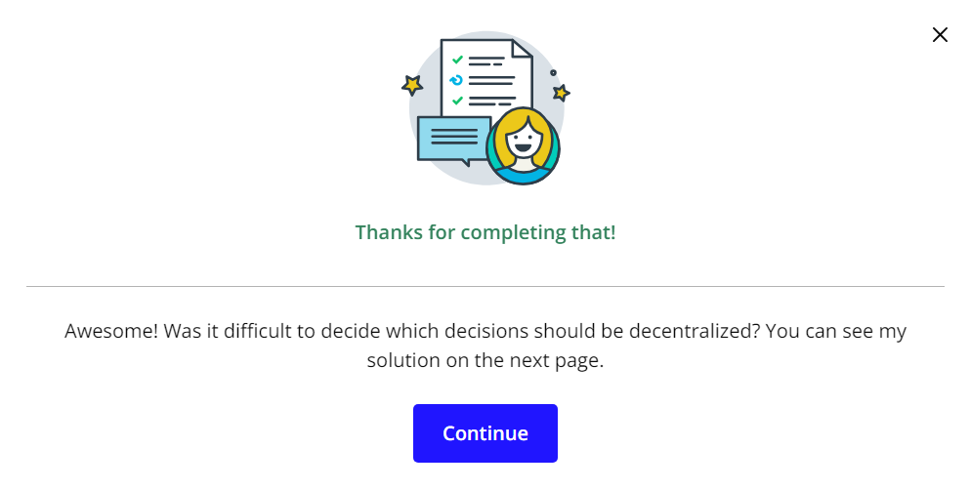

# Solution: Centralized vs. Decentralized Decisions

## My Solution

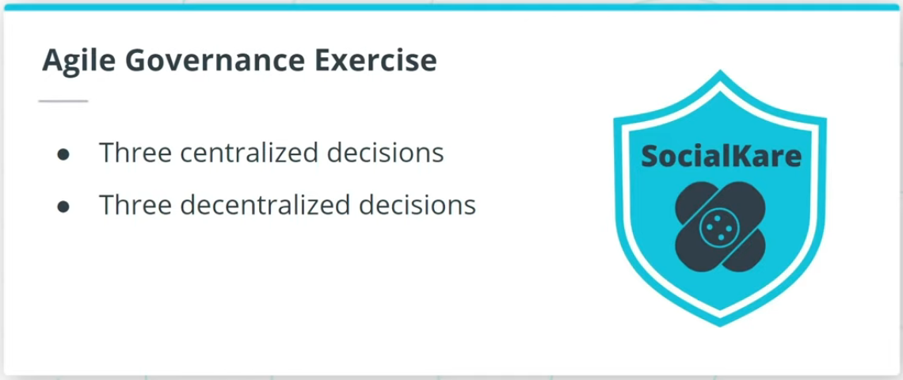

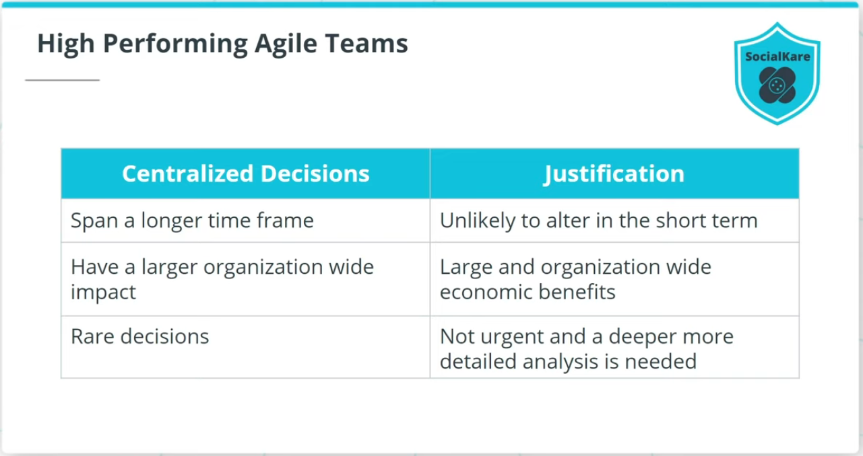

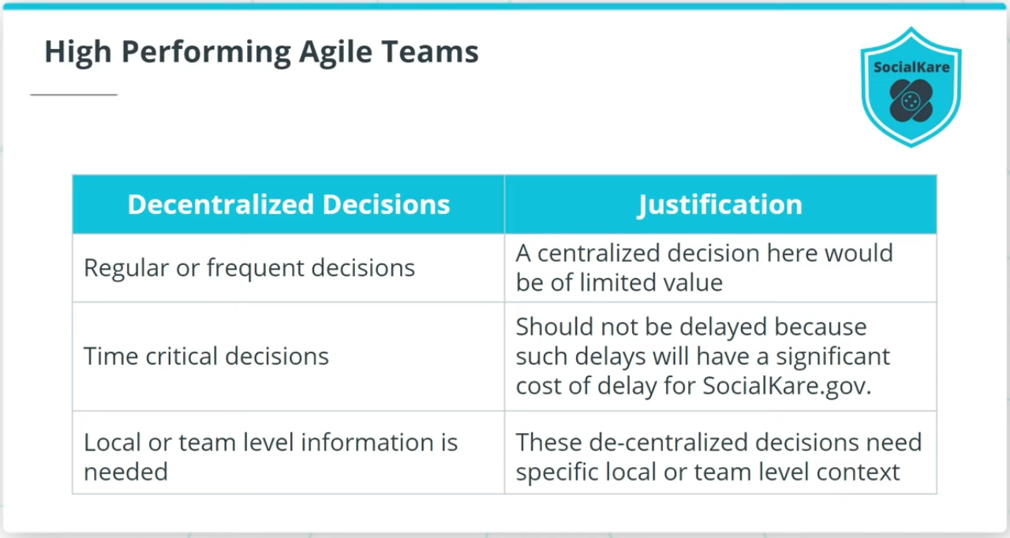

### **Agile Governance Body Model**

The exercise asked you to identify three decisions that should be centralized and three that should be decentralized at SocialKare.gov.

### **Centralized Decisions**

* Decisions that are unlikely to alter in the short term at SocialKare.gov; examples could include a significant technology platform selection or organizational structure alignment.
* Decisions that deliver large and organization-wide economic benefits at SocialKare.gov; examples here could include standard tools for managing the product life cycle or project life cycle, as well as decisions related to which vendor partner to set up an offshore relationship with.
* Decisions which SocialKare.gov’s leadership needs to make for rare decisions; examples of centralized decisions here include long-term product strategy, international expansion options and even decommissioning a product that has been in the market for a long time.

### **Decentralized Decisions**

* Decisions that address frequent and common questions that arise at SocialKare.gov, such as Product Backlog prioritization.
* Time-sensitive decisions, which should not be delayed because such delays will have a significant cost of delay for SocialKare.gov.
* Decisions that need specific local or team level context, such as self-organization of individuals to a new challenge that is emerging.

# What Kills High Performing Teams

## Pitfalls That High Performing Teams Should Avoid

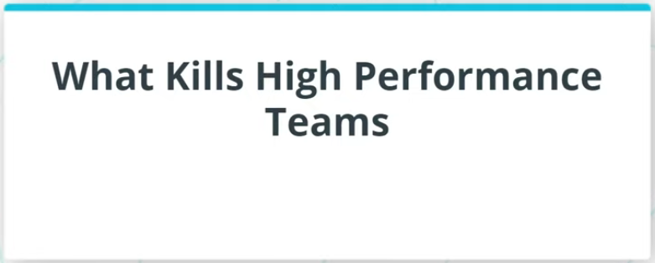

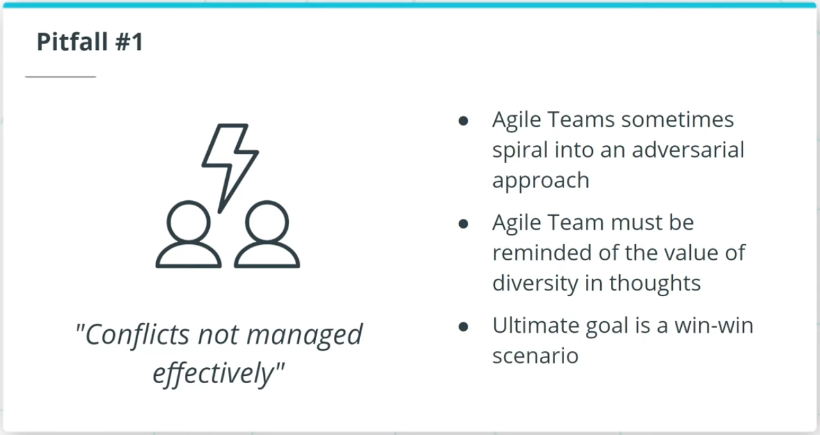

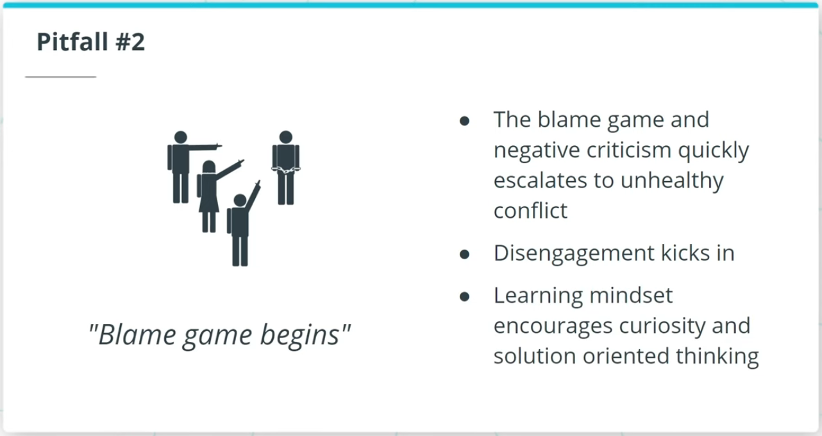

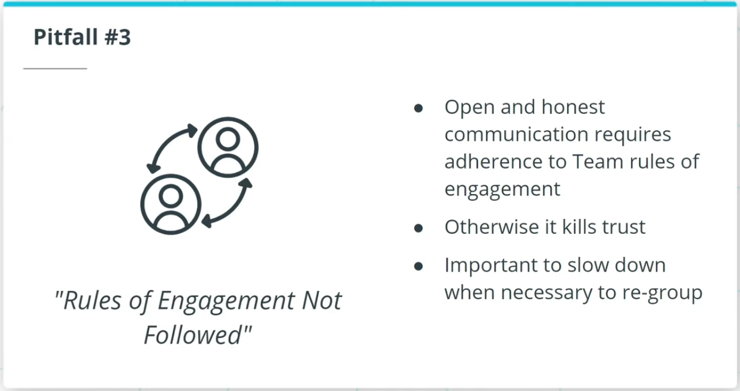

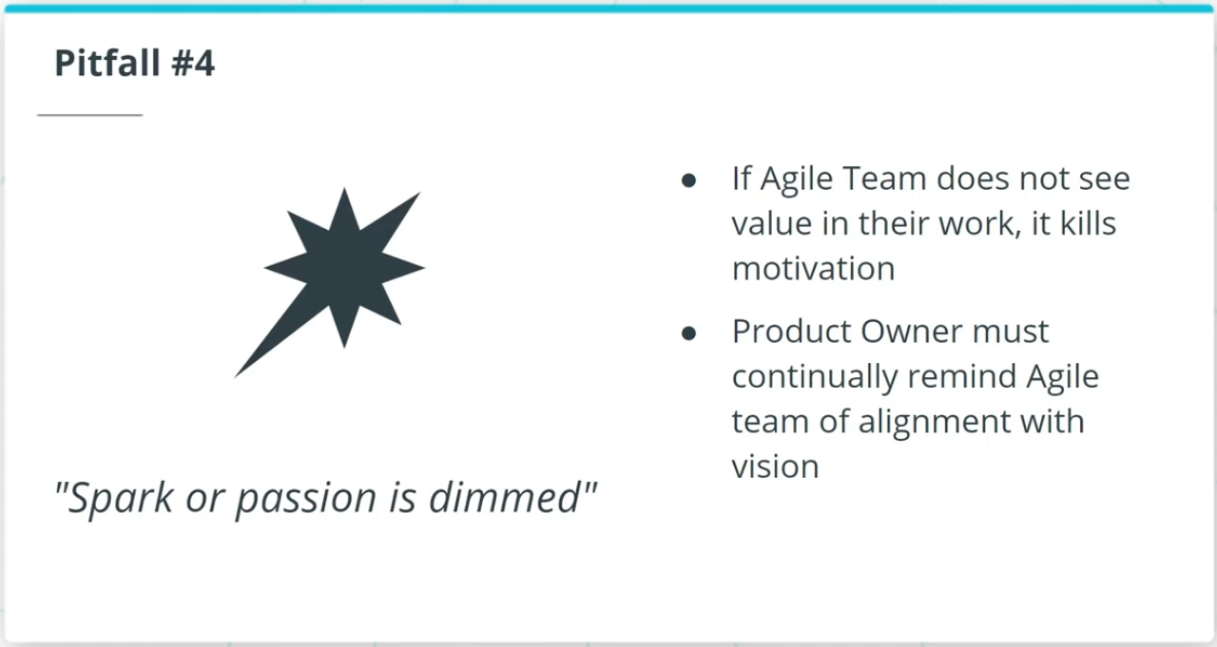

### **What Kills High-Performance Teams?**

* **Pitfall #1**: Conflicts are not managed effectively; it is important to regularly remind the Agile Team of the value of respectfully discussing differing opinions and suggestions.
* **Pitfall #2**: Blame game begins; there needs to be a tolerance for some failures since Agile Teams work in fast-paced situations. Such blame games and negative criticism quickly escalate to unhealthy conflict. The smarter and healthier outlook is to continue to keep the Agile Team on a learning mindset.
* **Pitfall#3**: Rules of Engagement are not followed; the Facilitator must ensure the Agile Team honors the agreed-upon rules of engagement and that team communications are frequent and relevant to avoid a high performing Agile Team from commencing its decline.
* **Pitfall #4**: Spark or passion is dimmed; if the Agile Team starts to perceive that their work is not as valuable, it can annihilate motivation. When the product vision starts to get foggy, the Product Owner needs to quickly step in to clarify.

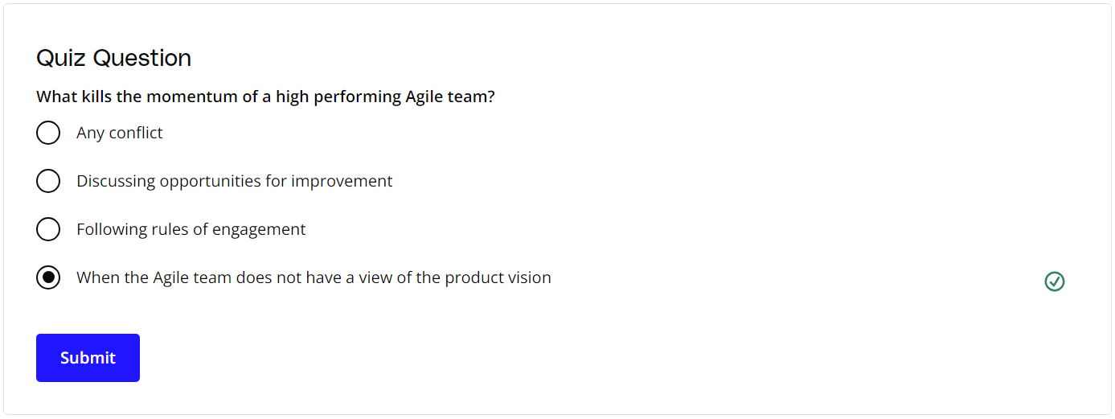

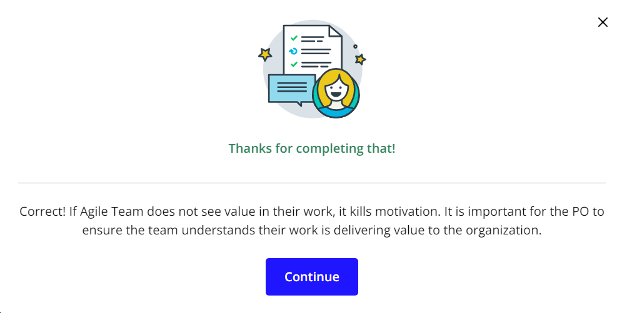

### **New Terms**

* **Blame Game**: Circumstances in an Agile team where team members try to blame each other for issues and challenges rather than working together to collaboratively resolve what they are encountering

### **Additional Resources**

* [**Governing Agile Teams(opens in a new tab)**](https://softwaremind.com/8-agile-mistakes-that-are-killing-your-development-projects-and-how-to-avoid-them/): This blog post covers various abysmal Agile implementation mistakes.

# Case Study

## Case Study

Now that you've learned the roles and responsibilities of various roles on an Agile team, in the video below, Chirag Doshi, a Principle Consultant at ThoughtWorks, tells his personal anecdote on how he built an Agile team as a Tech Lead.

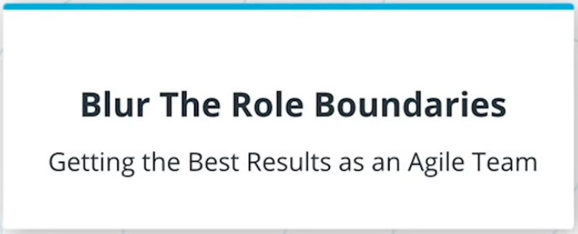

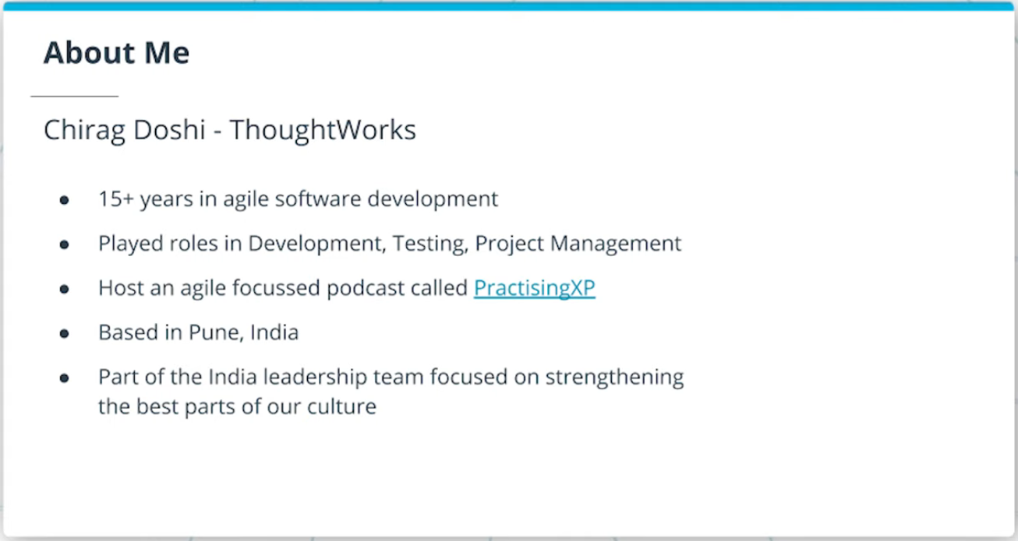

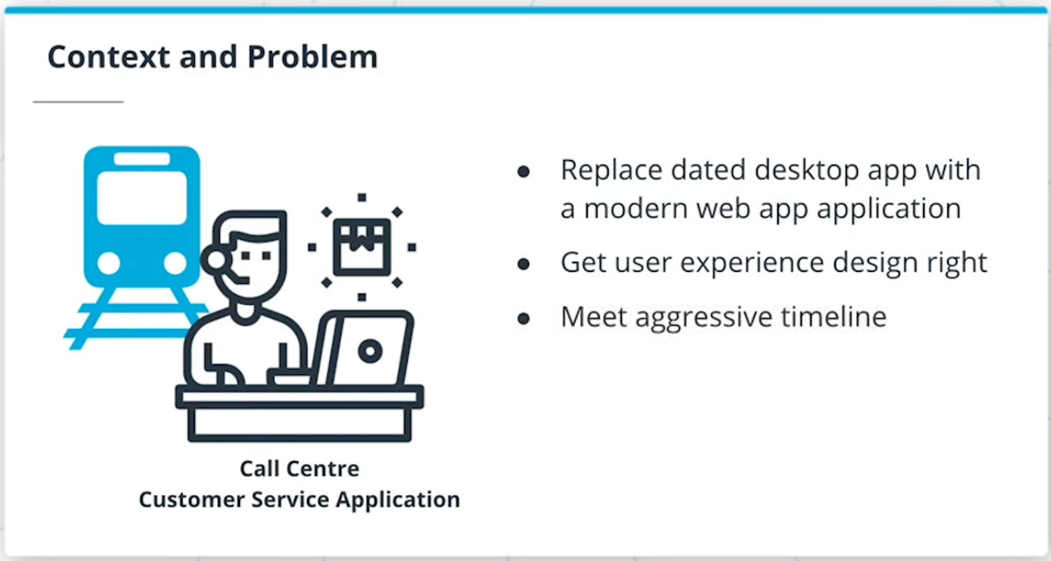

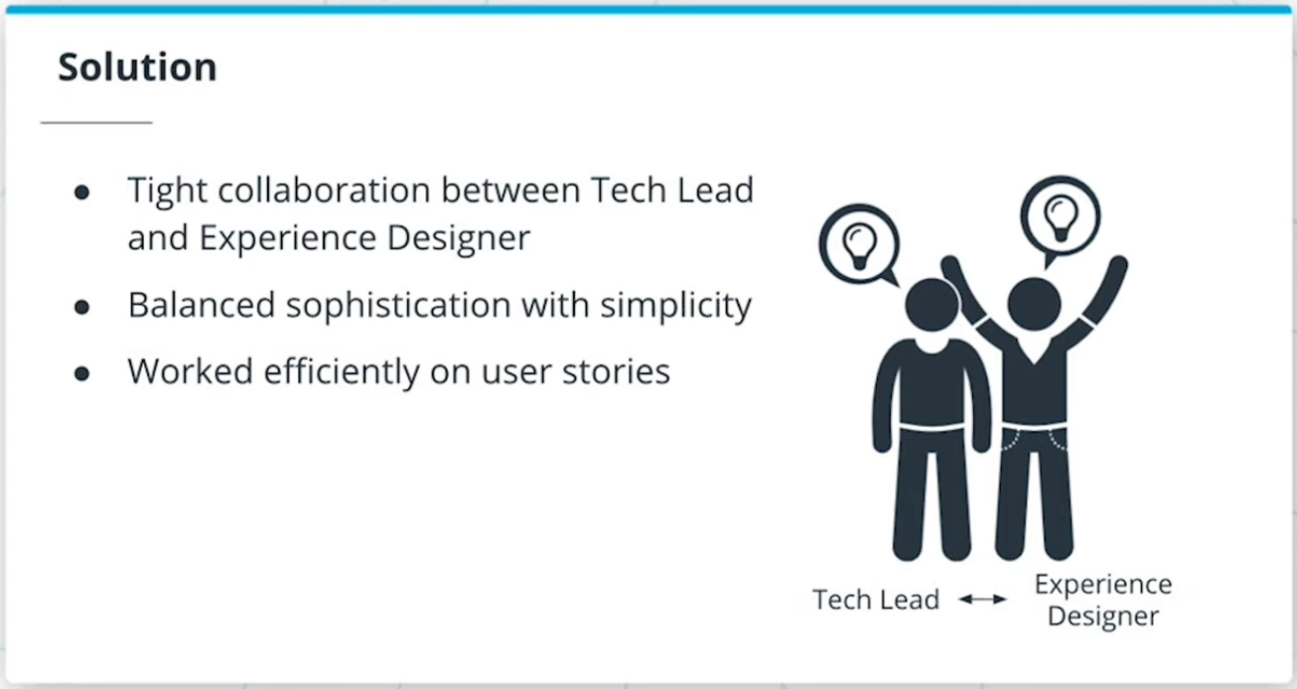

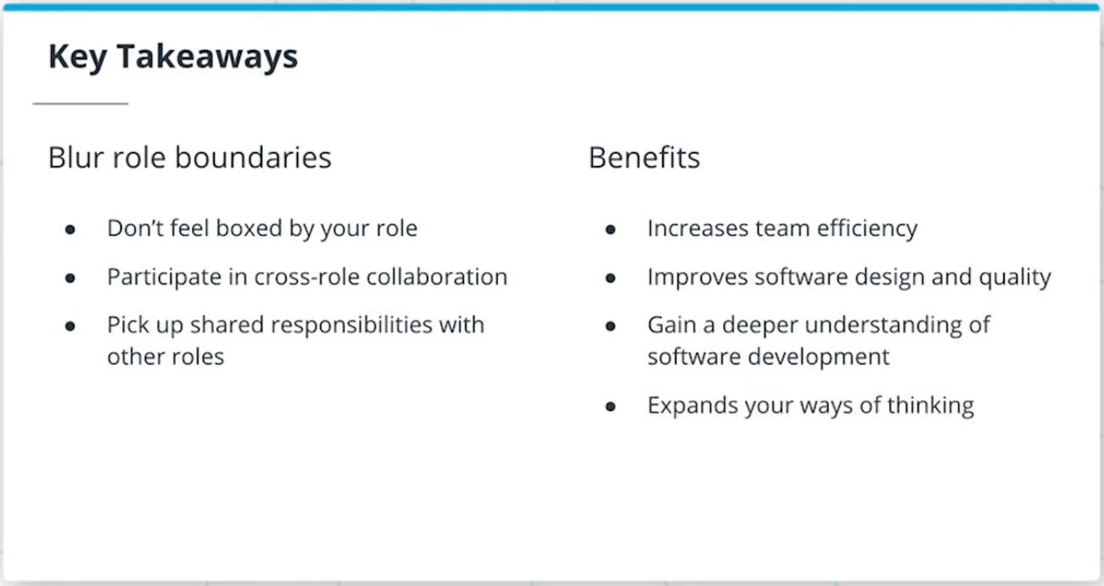

Mature Agile teams frequently **blur role boundaries within the team**. This flexibility results in higher levels of collaboration and co-creation and helps teams optimize for their overall team goals. It also creates a T-shaped profile for the team members.

The key takeaway from this case study is that if you are on an Agile team, consider blurring role boundaries. Don't feel boxed by your role. Collaborate and share responsibilities with people in other roles on the team. This increases team efficiency and improves the quality of the software you build. It also helps you gain a deeper understanding of software development and expands your ways of thinking.

# Lesson Recap

## What We Have Learned

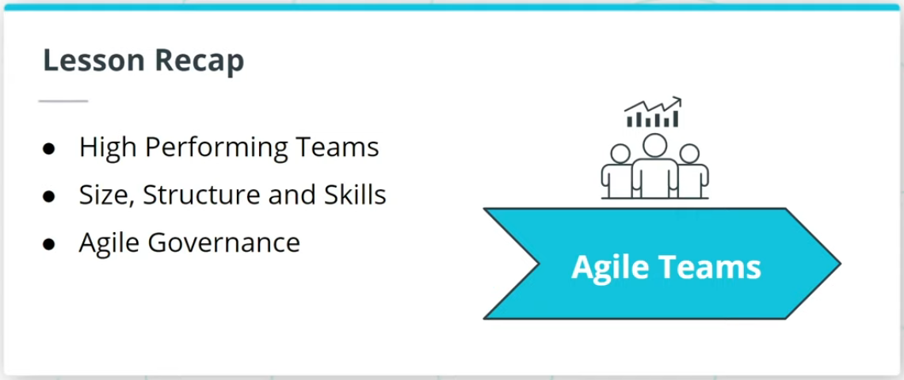

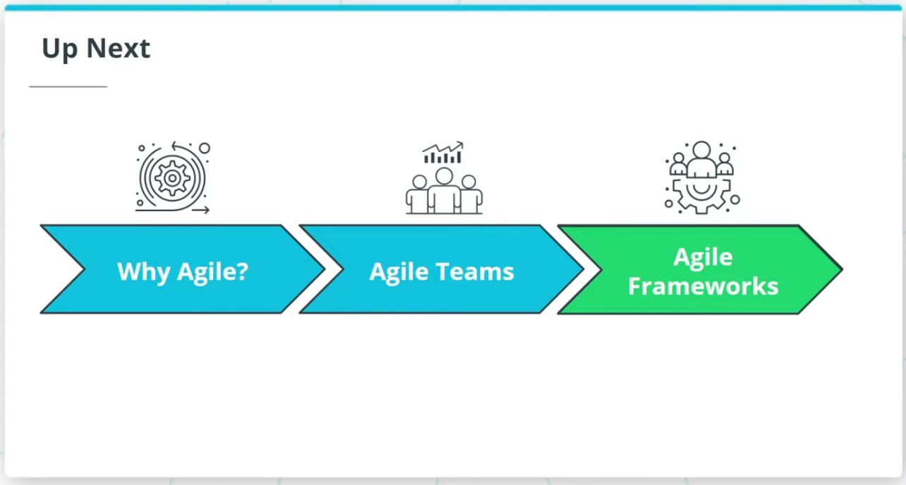

### **Lesson Recap**

In this lesson, we talked about:

* The characteristics of high performing Agile Teams.
* We then proceeded to talk about the size, structure, and skills of a High Performing Team. We discussed how Agile frameworks recommend a team size of between 5-12 skilled resources that are self-organizing and cross-functional with T-shaped skills.
* We then looked at Agile governance and how, based on the Agile Manifesto’s guidelines, Agile recommends a lightweight and simple approach to governance. Where possible, decentralized decision-making is encouraged.
* We finished up by talking about some pitfalls in which High Performing Agile Teams disintegrate and how to avoid those situations.

This lesson emphasizes how High Performing Agile Teams help organizations survive in such turbulent times. As the pace of change increases and the world of work makes ever greater demands on teams, high performing Agile Teams will become increasingly important.

In the next lesson, we will look at Agile Frameworks.

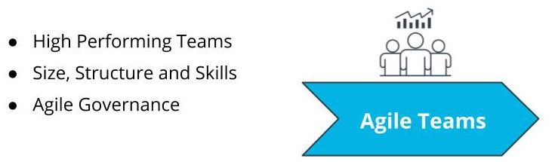

What We Covered In This Lesson